Speakers Introduction

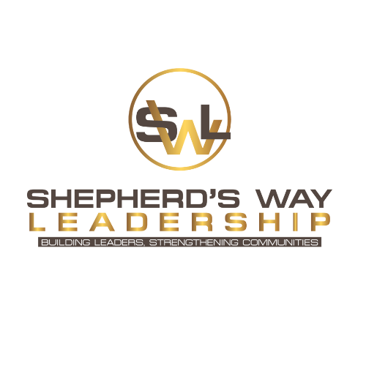
Jekiel ‘Jay’ Bishop

Ladies and gentlemen, hold on to your seats. Our next speaker comes packed with experience in leadership from every major arena — business, ministry, and combat. He is not here to give you theories, concepts, theses, or dissertations. No academic fluff, no watered-down ideas.
Jay Bishop is a former U.S. Army Infantry First Sergeant and combat veteran who has led men under fire. He’s a pastor who has walked with people through life’s hardest battles. And he’s the founder of Shepherd’s Way Leadership — an organization built on developing leaders of grit, character, and Christ-centered influence.
He calls leadership an optional obligation — a choice, not a title — and he doesn’t sugarcoat what it takes to step up and lead. Audiences who hear Jay are challenged, stretched, and changed.
Get ready for a message that will cut through excuses, ground you in biblical truth, and call you to lead at a higher level.
Please welcome — Jay Bishop.

