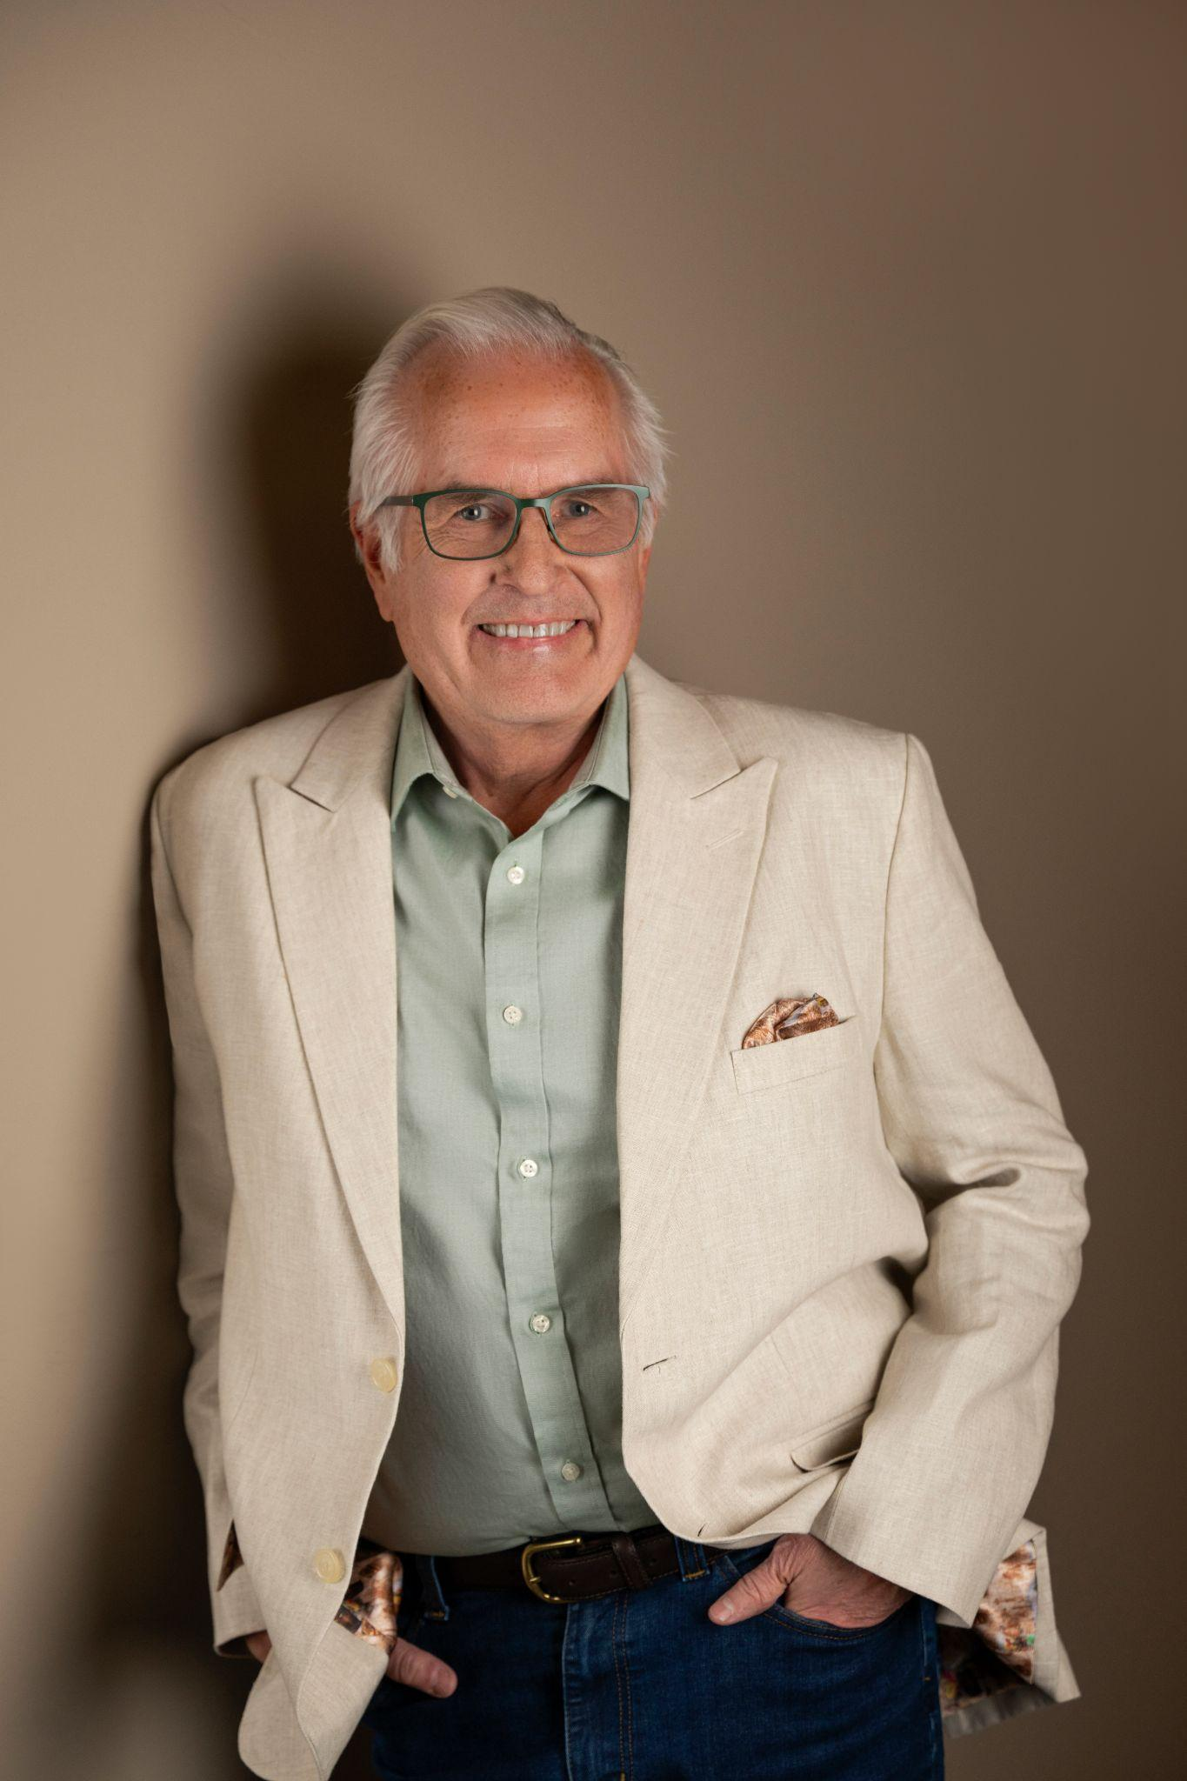

PATRICK DUNN
patrick@patrickdunnintl.com | +1 650.418.0507 | www.patrickdunnintl.com

Workshop Proposal:
“Lead with Soul: How to Lead When You’re Running on Fumes”

Abstract
Most leaders don’t suddenly realize they’re running on fumes. It creeps in — one more project, one more late night, one more urgent request that pushes the important things to the side. The work gets done, but it starts to cost more: focus scatters, patience wears thin, and the original joy and meaning in the work slip out of view.
This workshop gives leaders a chance to hit pause and reset with practical tools, not theory. Using the Lead with Soul framework — Reflect, Connect, Regenerate, and Service — participants take an honest look at where they’re out of alignment, name what’s draining their energy, and practice simple ways to reset in real time. They leave with language they’ve tried for harder conversations, five simple daily reset moves they’ve practiced in the room, and a focused 30–90 day plan to protect their energy and lead with more clarity, steadiness, and heart.

Learning Objectives
- Spot where they’re running on fumes and where their leadership is out of alignment
- Have more honest, trust-building conversations that lower friction with their teams
- Use five quick reset practices to restore energy and presence during the day
- Set clear filters for what gets their time and attention, based on who and what they serve
- Leave with a realistic 30–90 day Lead with Soul plan to protect their energy and lead with more steadiness and heart
“Patrick’s compelling storytelling and grounded facilitation bring vision, credibility, and heart to every session he leads, inviting people into honest reflection and practical action.”
- Dr. Angele Kedaitiene, European Commission Climate Ambassador

References
Barbara McChesney, President, Rotary Club of Windsor | barbsmcc@gmail.com | 707.477.1518
Elena Spaulding, Senior Vice President, Broadridge | haewafy@gmail.com | 862.243.2263

