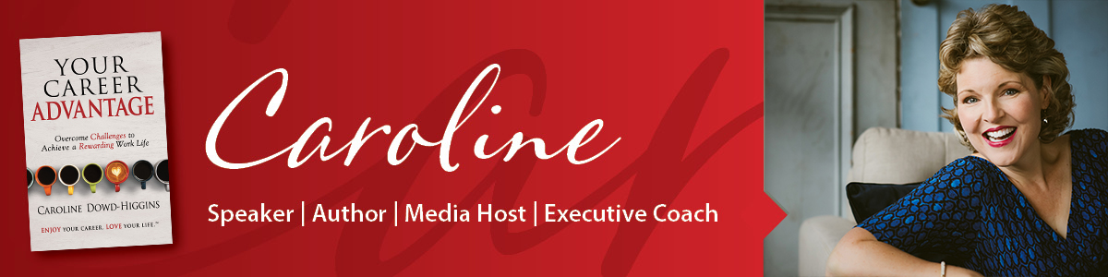

STAGE INTRO – Caroline Dowd-Higgins

Caroline Dowd-Higgins believes Banishing Burnout will Ignite Productivity
and Unleash Potential in your organization. A former executive leader,
Caroline has designed and implemented innovative talent and professional
development ventures in organizations for 20 years. Her podcast, Your Working Life reaches 1 million listeners in 34 countries and her bestselling books empower individuals thrive in life and career.

A former professional opera singer, she knows her way around a stage and delights in speaking with audiences around the world. She has a slight obsession red licorice and she and her husband are the proud parents of rescue Walker Hounds, Spencer and Brody.

Ladies and gentlemen...Caroline Dowd-Higgins.

