TELL ME ABOUT YOUR BUSINESS. *: Startup Science provides an online platform that actively guides entrepreneurs through the entire lifecycle of successfully building and funding their company, from inception to exit ([www.startupscience.io](http://www.startupscience.io)). It is complementary to accelerators, university programs and other support systems, but unlike these high-touch, geographically anchored models it can scale limitlessly by virtue of being entirely software/internet-based. This has the added benefit of allowing penetration of untapped emerging countries and underserved populations where more traditional support systems don’t yet exist. Participating entrepreneurs provide detailed, standardized data, including real-time information on their operations, through the platform.

The Startup Science platform addresses all the challenges normally associated with investing in early stage companies: it allows investors to make decisions based on real data and actual performance rather than pitch decks; it allows the use of machine learning to automate screening of the entire global database against an investor’s thesis (and eventually will allow automated investment based on thesis fit) increasing volume of deal flow; and it improves the success rate of early stage companies by providing entrepreneurs with high quality education, vetted support services, and a world-wide network of fellow entrepreneurs and university partners.

2. HOW'D YOU GET INTO YOUR BUSINESS/LINE OF WORK? *

Over that rough-and-tumble seventeen-year spell, I built Affiliate Traction up into an industry leader—the first agency to go worldwide—despite almost losing everything twice, during the dotcom bomb in 2000, and again during the 2008 crash. After each setback, I persevered and rebuilt. Then, in 2016, sold the startup to eBay Enterprise Marketing Solutions as part of a $925M transaction that included digital marketing pioneer Pepperjam and the e-commerce giant Magento, both later sold to Partnerize and Adobe, respectively. The deal won four private equity industry awards in the $250M to $1B transaction category.

Once the transaction was complete, I was asked to develop a technical, operational, and product vision across the now much larger combined startup as chief strategy officer, then later to execute the strategy in the role of chief technology officer. After the technology was built, the go-to-market (GTM) plan was implemented to great success as the new combined company sold again to Partnerize, a partnership management solution platform.

After three years, I was able to step down to focus once again on what I love: building startups. Clear of all prior commitments, I could finally start to give back. I initially sought out politics, working as a chairman for a congressional candidate, but I was left disenchanted by the political system’s operational playbook. I found myself looking for another way to give back. I’ve since started an investment syndicate (a group of like-minded investors) and launched a founderial education and software startup targeting corporations, investors, and startup assistance programs (SAPs), like incubators and accelerators. Both of these support the early-phase startup ecosystem in their own way, and are ultimately focused on dropping the proverbial 90 percent startup failure rate.

3. TELL ME ABOUT A TIME YOU ALMOST QUIT THE BUSINESS, OR EXPERIENCED A SETBACK OR OTHER SURPRISE IN YOUR BUSINESS. *

When the market crashed in 2008, my startup nearly collapsed. In one of the hardest moments of my life, I had to lay off sixty-five employees. Watching their faces and knowing what this meant to their families was a painful experience that I will never forget. Then, I had to look into my wife’s eyes and tell her we had to move into a moldy old studio apartment with our two-year-old, relocate the startup headquarters into a barn, and rally a handful of my remaining employees to rebuild the company from the ground up.

4. HOW DID YOU MOVE PAST THAT ROADBLOCK? *

While in the process of rebuilding Affiliate Traction, I became a student of the endless list of business operating systems, including Six Sigma, 4DX, Agile, Lean[M1] , OGSM, OKRs, and everything else I could find. I tested, tweaked, and applied them to Affiliate Traction. Things eventually got better—*much* better. We signed new customers, including some household names and major brands, like Guess. We hired new employees and brought back some of the old crew. Eventually, in 2016, seventeen years after we’d launched, Affiliate Traction was acquired by eBay Enterprise Marketing Solutions in the deal I mentioned earlier. But I *also* knew that, with a bit more guidance and greater knowledge of what was required to succeed, I could have made it much faster and with fewer white-knuckle moments along the way.

5. IF YOU COULD GO BACK IN TIME AND GIVE YOUNGER YOU SOME ADVICE, WHAT WOULD IT BE? *

In the beginning of a startup journey, it’s best to pay close attention to all the good advice you receive and to completely ignore all the bad advice you receive. Of course, the trick lies in figuring out which is which. In the beginning, *everyone* has an opinion. But not everyone has an opinion that’s worth listening to. Some people have their own agendas.

6. I NEED A BIO. YOU CAN PASTE YOURS IN BELOW:

Greg Shepard has built and sold 12 liquidity events in BioTech, TransitTech, AdTech, and MarTech. He is a Forbes Book Author/Contributor and has been featured or quoted in publications like Fortune, Entrepreneur, The New York Observer, The DEAL, and Thrive Global. A recipient of four private equity awards for transactions between $250M to $1B, Greg has appeared on TV, Radio, and popular Podcasts, and has been featured as a TEDX and Keynote speaker at multiple universities and conferences worldwide. Greg is the author of the best selling book The Startup Lifecycle.

7. Headshot

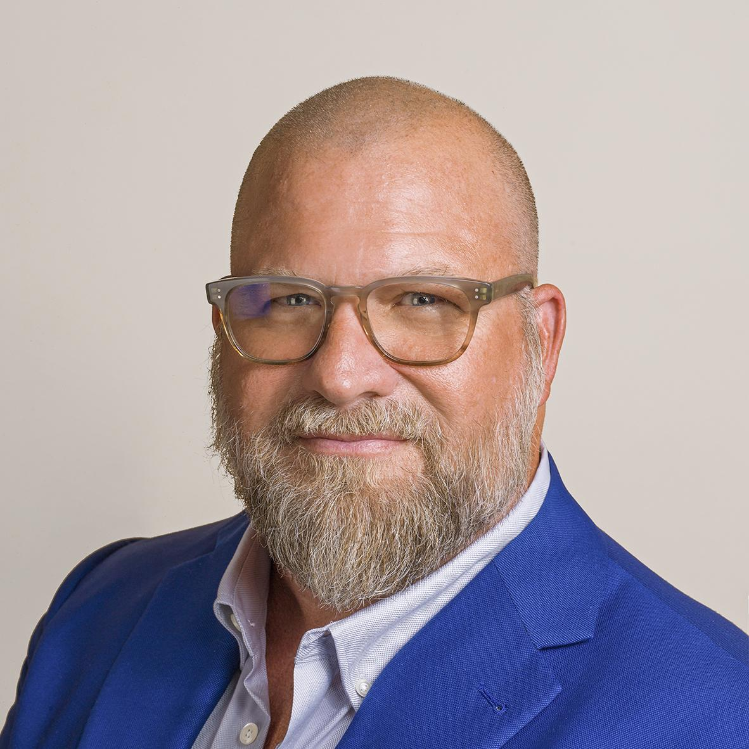

Socials

Facebook: <https://www.facebook.com/GregoryJShepard?mibextid=ZbWKwL>

LinkedIN: <https://www.linkedin.com/in/gregshepard?utm_source=share&utm_campaign=share_via&utm_content=profile&utm_medium=android_app>

X: <https://x.com/GregShepard_?t=T_s1WyUWZAYchxi3FwY-yQ&s=09>

Youtube: <https://youtube.com/@gregoryshepard?si=xhfHn_cIsZunfTvG>