BC LEADERSHIP CO.
———————
MEDIA KIT

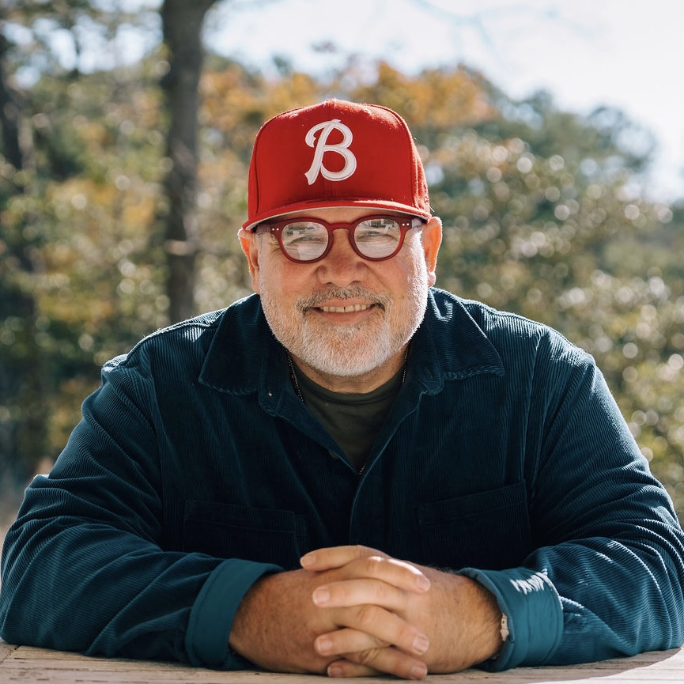

Brek Cockrell
Transformational Life & Leadership Coach
Speaker · Podcaster · Coach · Bridge Builder

bc@bcleadershipco.com | 716-310-2210
bcleadershipco.com
39 Beatrice Ave, Buffalo, NY 14207

The Story

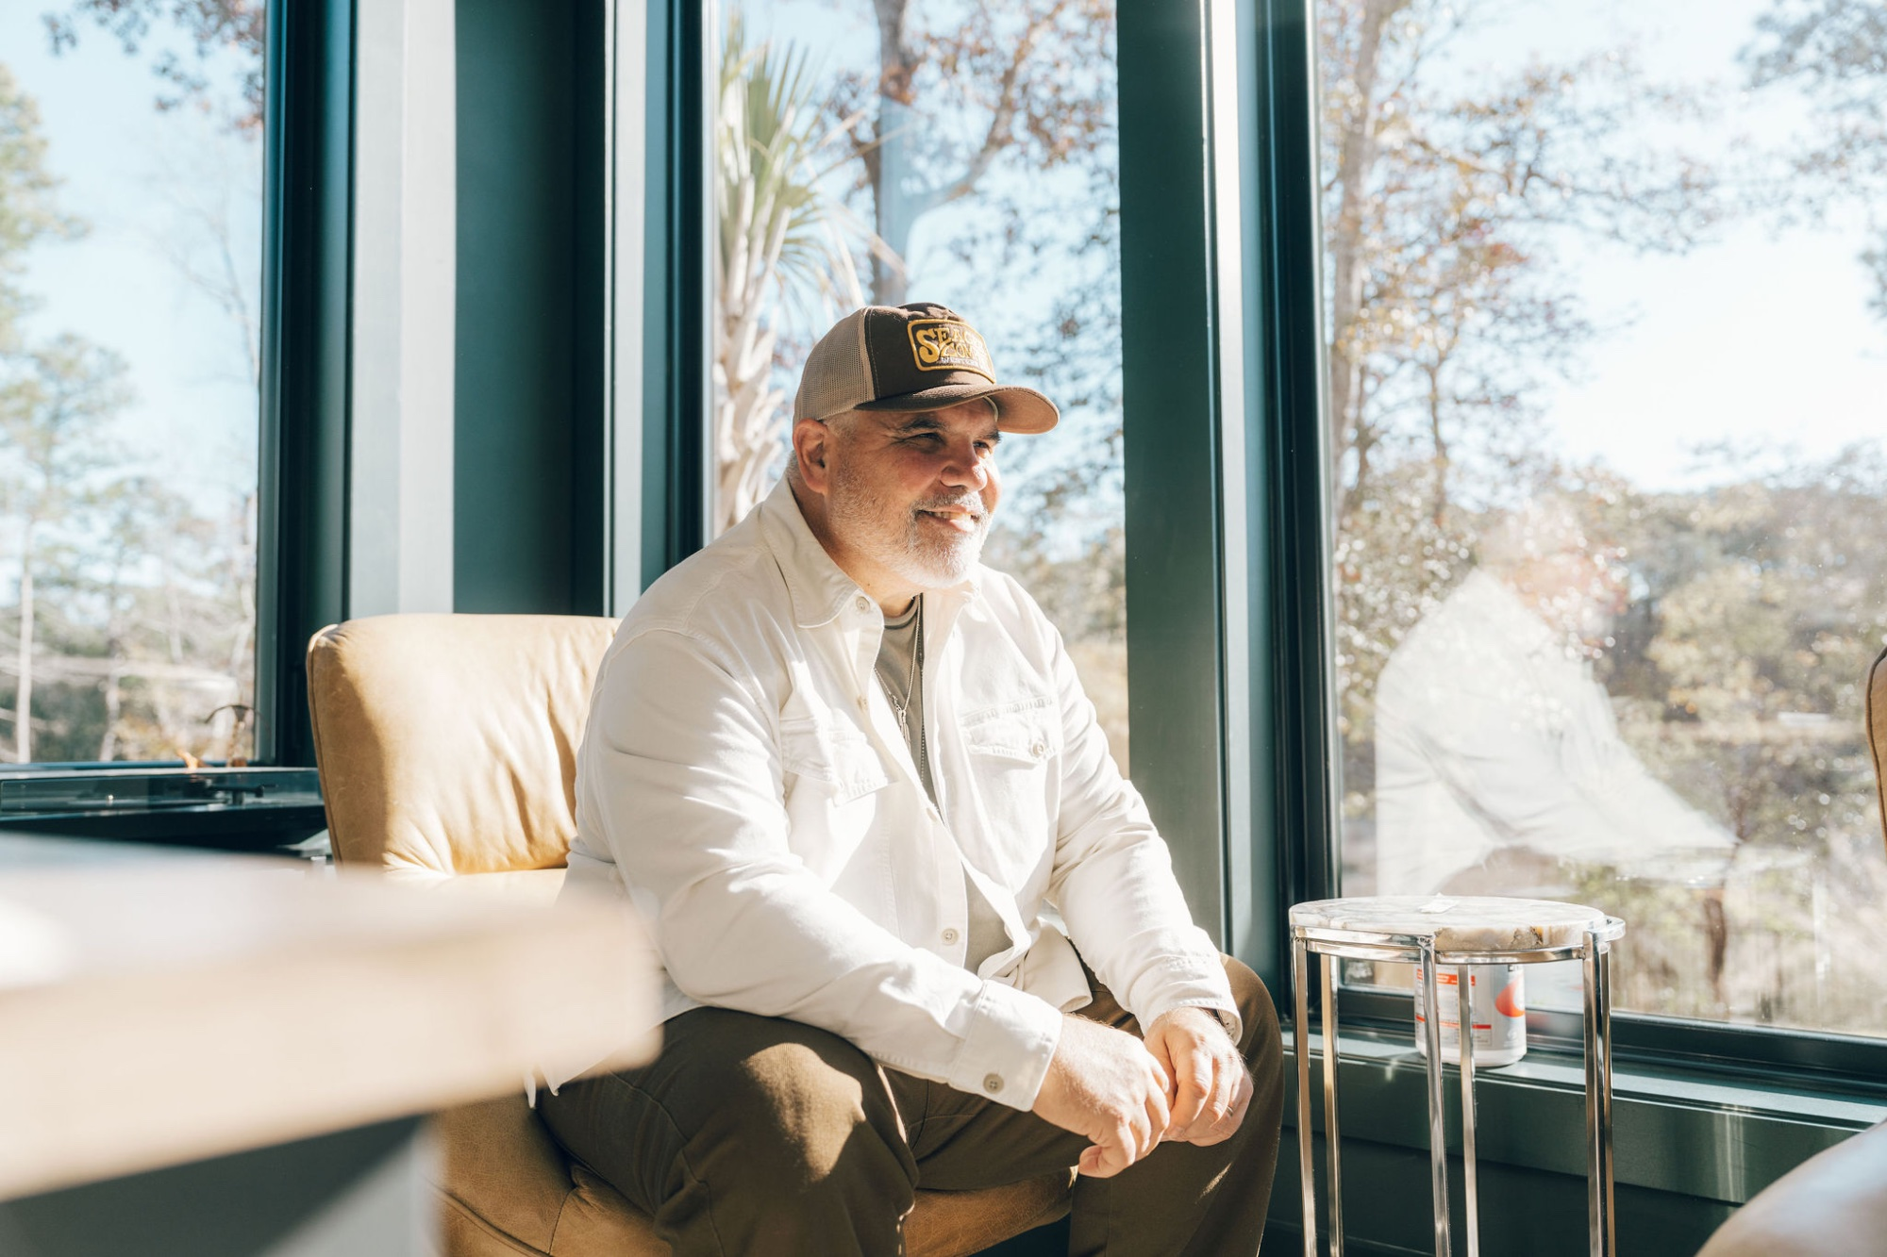
“My WHY is to help every person in every place get repeated opportunities to hear and see and touch and taste the love of Jesus by building bridges and turning on lights.”
— Brek Cockrell
Brek Cockrell didn’t build a coaching practice from a textbook. He built it from the trenches — 25 years of pastoring, leading through conflict, planting a church in the city of Buffalo, founding a nonprofit, and learning firsthand that leadership is never just about strategy. It’s about trust.
In 2007, Brek launched Renovation Church in Buffalo, NY, stepping into a city that needed bridge-builders, not more walls. He went on to found the Xcel Leadership Center, a nonprofit committed to leadership development, and became certified in restorative justice — work that deepened his conviction that the best leaders don’t just manage people, they restore them.
After stepping out of the pastorate in August 2023, Brek made a bold pivot. In January 2024, he officially launched BC Leadership Co. with a clear mission: to create environments and experiences that help leaders take their next best step. He earned his Master’s in Executive Coaching and Consulting from The Townsend Institute at Concordia University, studying under thought leaders like Dr. John Townsend, and bringing that same depth to every leader he serves.
Today, Brek serves as a transformational life and leadership coach, keynote speaker, and host of the Your Next Best Step podcast. He works with individuals, teams, and organizations who are ready to move from where they are to where they want to be — one honest, courageous step at a time.
——————————
Life Verse: Proverbs 3:5–6, 13–15

Why Book Brek?

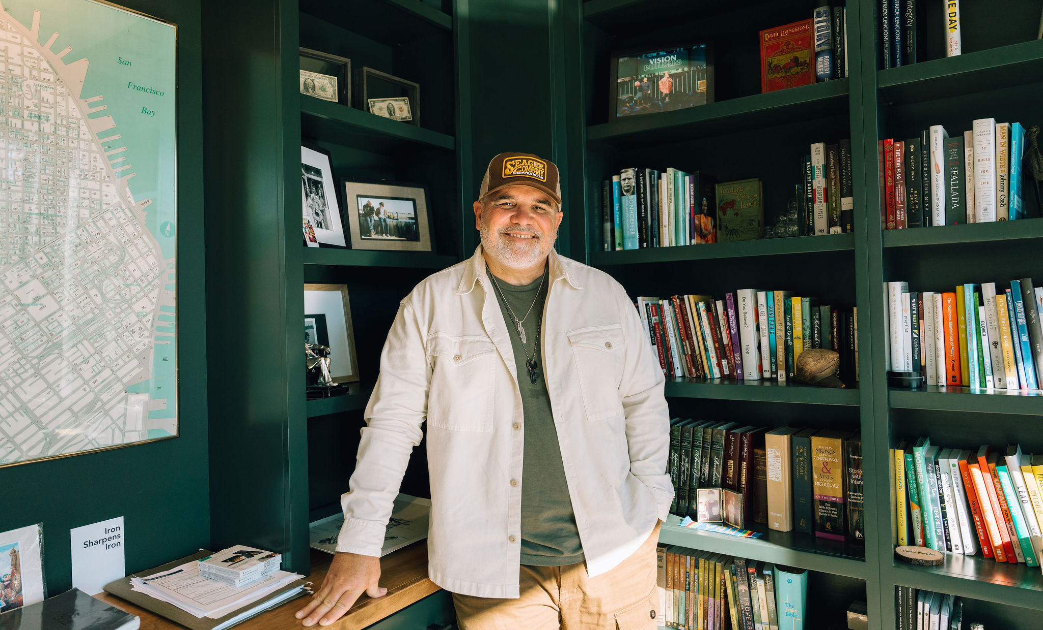
When you bring Brek Cockrell into your room, you’re not getting a polished presenter who delivers content from a distance. You’re getting a leader who has been in the fire, knows what it costs to lead with integrity, and has the rare ability to make a room of 20 or 2,000 feel like they’re sitting across the table from a trusted friend.

AUTHENTIC  Brek leads with vulnerability. He doesn’t hide behind expertise — he shares from experience. Audiences connect with him because he’s real. | TRANSFORMATIONAL  Every session is designed to move people, not just inform them. Brek creates moments where leaders see themselves clearly — and decide to take action.
ADAPTABLE  Keynote, workshop, half-day intensive, or full-day experience — Brek tailors every session to your audience, culture, and goals. No canned talks. | TRUST-CENTERED  Brek’s core leadership principle — E.D.O.T. (Everything Depends on Trust) — isn’t just a tagline. It’s the lens through which every session is built.

What Sets Brek Apart
25+ years of hands-on leadership experience in urban ministry, church planting, nonprofit leadership, and restorative justice work. A rare combination of academic depth (Master’s in Executive Coaching) and real-world grit. Influenced by thought leaders like Dr. John Townsend, Henry Cloud, John Maxwell, Brené Brown, Adam Grant, Simon Sinek, Laysha Ward, and Don Miller. A coaching philosophy rooted in trust, empathy, curiosity, and the belief that every leader has a next best step.

Signature Speaking Topics
Every session is designed to create an environment where leaders can slow down, get honest, and take their next best step. All topics can be customized and delivered as keynotes (30–60 min), interactive workshops (60–90 min), half-day intensives, or full-day experiences.

01 | E.D.O.T. — Everything Depends on Trust
Trust is the soil from which everything grows — in teams, organizations, families, and communities. But trust doesn’t happen by accident. This session gives leaders a practical framework for building, sustaining, and repairing trust in every environment they lead. Participants will leave with tangible tools and an honest self-assessment of where their trust culture stands today.
Best for: Leadership teams, organizations navigating change, corporate retreats, pastoral teams

02 | Your Next Best Step
Most leaders don’t need more information — they need clarity. This session cuts through the noise and helps leaders identify exactly where they are, get honest about what’s holding them back, and take one powerful step forward. It’s practical, personal, and rooted in the belief that transformation doesn’t require the whole staircase — just the next step.
Best for: Conferences, personal development events, executive off-sites, churches, leadership cohorts

03 | Building Bridges & Turning on Lights
In a world that tends toward division, this session explores what it looks like to be a bridge-builder. Drawing from Brek’s deep experience in restorative justice and urban ministry, participants will be challenged to lead with empathy over transaction, curiosity over certainty, and trust over suspicion. This is more than a talk — it’s an invitation to become the kind of leader every room needs.
Best for: Community organizations, churches, DEI events, justice-focused gatherings, civic groups

04 | The Leader’s Locker Room
Inspired by the Your Next Best Step podcast, this interactive workshop creates a “locker room” environment where leaders can take off the armor, get real about where they’re struggling, and become rooted in what matters most. This is not about performance — it’s about presence. Leaders will walk away with renewed clarity, deeper self-awareness, and a commitment to lead from wholeness, not hustle.
Best for: Leadership retreats, executive teams, pastoral gatherings, men’s/women’s events

05 | Custom Topic
Have a specific theme, challenge, or audience need? Brek is happy to develop a fully custom keynote or workshop tailored to your event’s goals. From team health to navigating transitions to leading through uncertainty, Brek brings the same depth, warmth, and practical wisdom to every topic he tackles.
Best for: Inquire at bc@bcleadershipco.com

Engagement Options
Brek offers flexible formats to meet your event’s needs and budget. Every engagement is customized through a pre-event discovery call to align content with your audience, theme, and goals.

KEYNOTE ADDRESS
30–60 minutes
A high-impact keynote tailored to your event’s theme. Includes a pre-event discovery call, customized content, and a follow-up resource for attendees.
Includes: Discovery call, customized keynote, attendee takeaway

INTERACTIVE WORKSHOP
60–90 minutes
A deeper, hands-on session designed for engagement and application. Participants don’t just listen — they interact, reflect, and leave with an action plan. Perfect for breakout sessions and team trainings.
Includes: Discovery call, customized workshop, handouts/worksheets, group activities

HALF-DAY INTENSIVE
3–4 hours
A focused, immersive experience combining teaching, facilitation, and guided exercises. Ideal for leadership teams ready to do real work together — building trust, identifying blind spots, and mapping their next best steps as a team.
Includes: Pre-event team assessment, customized curriculum, facilitated exercises, team action plan

FULL-DAY LEADERSHIP EXPERIENCE
6–8 hours
The ultimate deep dive. A full day of content, coaching, and collaboration designed to catalyze lasting change. This experience can be structured as a single-topic deep dive or a multi-session day covering several themes. Ideal for annual retreats, leadership summits, and organizational transformation.
Includes: Pre-event consultation, full-day curriculum, all materials, follow-up coaching call (30 min)

Pricing is customized based on event scope, audience size, travel requirements, and format. Contact bc@bcleadershipco.com for a personalized proposal.

Podcast & Media

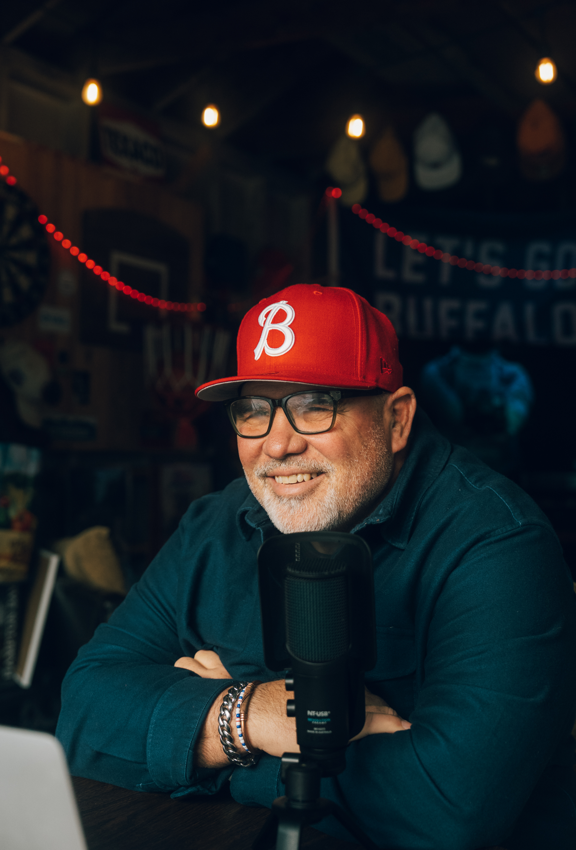
Your Next Best Step Podcast
The Leaders’ Locker Room — where leaders go to slow down, get real, and become rooted so they can lead others better.

The Your Next Best Step podcast is Brek’s weekly invitation to leaders everywhere to take off the armor, step out of the hustle, and get honest about what it takes to lead well. Each episode features candid conversations, practical coaching insights, and stories from leaders who are learning to lead from a place of wholeness rather than performance.

Recurring Themes
Trust as the foundation of leadership. Navigating transitions and seasons of change. The intersection of personal growth and professional effectiveness. Restorative leadership in divided environments. Vulnerability as a leadership strength. Finding your next best step in any season.

Where to Listen
[Insert podcast platform links here — Apple Podcasts, Spotify, YouTube, etc.]

——————————
Interview Topics
Brek is available for podcast interviews, panel discussions, media features, and guest columns. He speaks naturally and authentically on a wide range of leadership and personal growth topics.

Leadership & Trust  Why trust is the single most important currency in leadership. How to build, measure, and repair it. | Transitions & Reinvention  Leaving a 25-year career in ministry to start something new. What it looks like to make a bold pivot at any stage.
Restorative Justice & Empathy  How restorative practices transform communities, organizations, and relationships. Choosing empathy over transaction. | Faith & Leadership  Integrating faith and leadership without being preachy. How a life verse in Proverbs shapes real-world leadership decisions.

What People Are Saying

“I’ve had the privilege of watching BC engage a room in ways that very few speakers can. He doesn’t just deliver a talk — he creates an experience. Whether he’s addressing nonprofit leaders, corporate teams, or community stakeholders, BC has an extraordinary ability to meet people exactly where they are and move them toward where they need to be. What sets BC apart is his authenticity. He brings a rare combination of vulnerability, humor, and hard-won wisdom that makes every audience feel seen and challenged at the same time.”
— Kyria Stephens, CEO, Intersect Buffalo
——————————
“As someone who coaches high-performing sales professionals across the country, I know the difference between a motivational speaker and a transformational one. BC is the latter. He has a gift for getting past the surface-level noise and straight to the heart of what’s holding leaders back. BC doesn’t just inspire people for an afternoon. He gives them practical tools and a mindset shift that sticks long after the event ends. I recommend him without hesitation for any organization that’s serious about developing its leaders.”
— Joshua Dean, National Sales Coach, Homeowners Financial Group
——————————
“We brought BC in to speak to our leadership team, and the impact was immediate and lasting. He has a remarkable ability to make big ideas accessible without watering them down. What impressed me most was how BC tailored his message to our specific challenges. It wasn’t a canned presentation — it was a conversation that happened to move an entire room. BC brings a combination of strategic thinking, emotional intelligence, and genuine care for the people in front of him.”
— Scott Traylor, VP of Online and Marketing, Bryant & Stratton College
——————————
“Brek Cockrell is a phenomenal speaker. He consistently delivers messages that are both inspiring and thought-provoking. He has a unique way of presenting information that not only makes you reflect but also challenges you to grow. What stands out most is how personable and relatable he is. No matter your background or walk of life, Brek has a way of connecting with people that makes you feel seen, understood, and encouraged. He will motivate, inspire, and empower any audience he stands before.”
— Salley Nycole Crews, Entrepreneur & Social Media Influencer

Frequently Asked Questions

How far in advance should we book?
Brek recommends booking at least 4–6 weeks in advance to ensure availability and allow time for the pre-event discovery call and content customization. For large events or full-day experiences, 8–12 weeks is ideal.

Does Brek use slides or presentation materials?
It depends on the session. For some keynotes, Brek prefers to speak without slides to create a more intimate, conversational experience. For workshops and intensives, slides, handouts, and interactive materials are often included. This will be confirmed during the discovery call.

Can Brek customize his talk for our specific audience?
Absolutely. Every engagement begins with a discovery call where Brek learns about your audience, culture, challenges, and goals. He doesn’t do canned talks — every session is tailored.

What size audience is Brek best suited for?
Brek is equally effective with intimate groups of 20 and large audiences of 2,000+. His style is warm, engaging, and interactive regardless of room size.

Does Brek offer virtual or hybrid speaking?
Yes. While in-person engagements are preferred for maximum impact, Brek is experienced with virtual and hybrid formats and can adapt his content and delivery accordingly.

Can we record or livestream the session?
Recording and livestreaming are allowed with prior written approval. Please discuss this during the booking process so it can be included in the speaking agreement.

Does Brek sell books or resources at events?
Brek may request a table to display resources, books, or promotional materials. This can be discussed during the planning process.

What is Brek’s cancellation policy?
Details are outlined in the speaking agreement. In general, the deposit is non-refundable but Brek works collaboratively with organizers to reschedule whenever possible.

How do we get started?
Reach out to bc@bcleadershipco.com or call 716-310-2210. Brek or his team will respond within 48 hours to schedule a discovery call and begin the process.

Photo Gallery
High-resolution photos available for promotional use. Contact bc@bcleadershipco.com for full-resolution files.

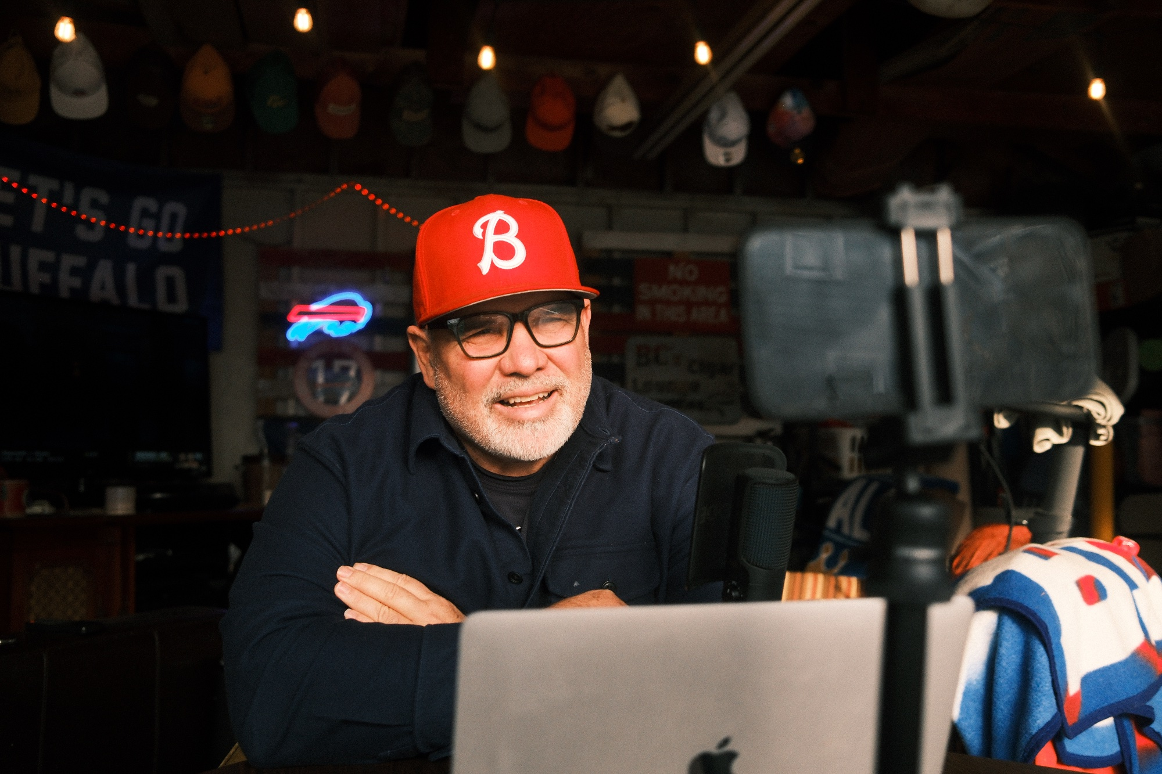 | 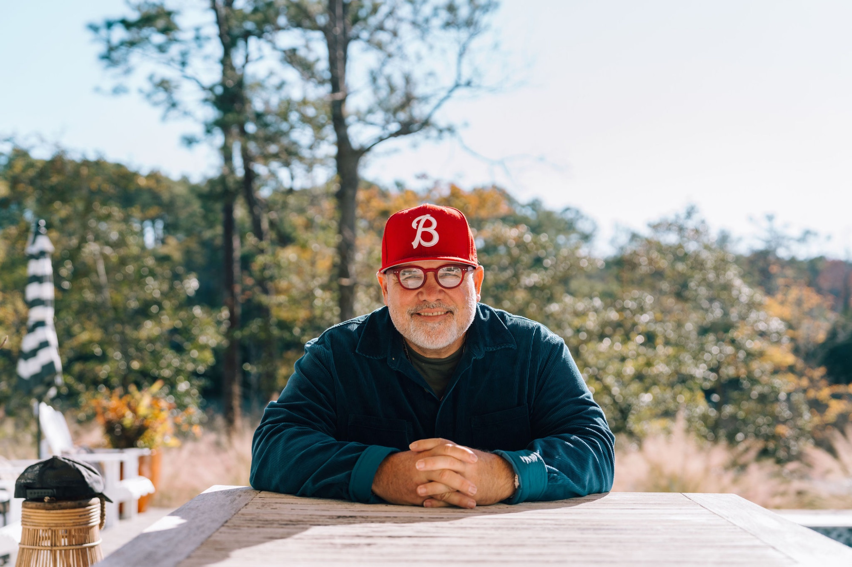

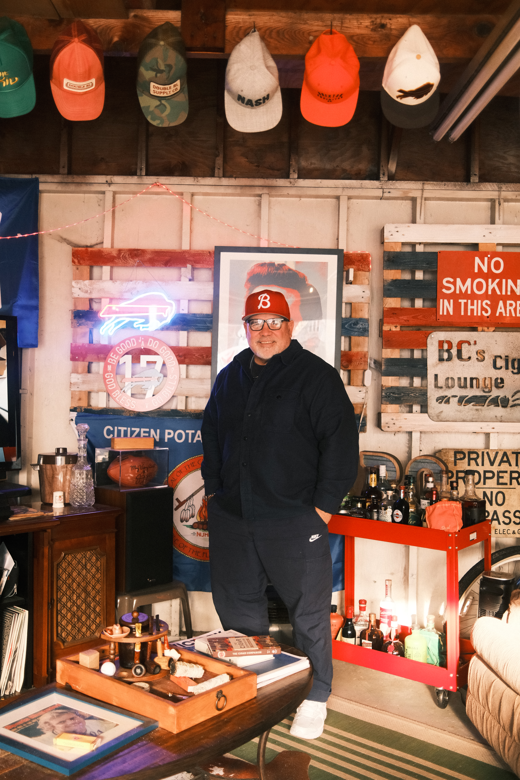 | 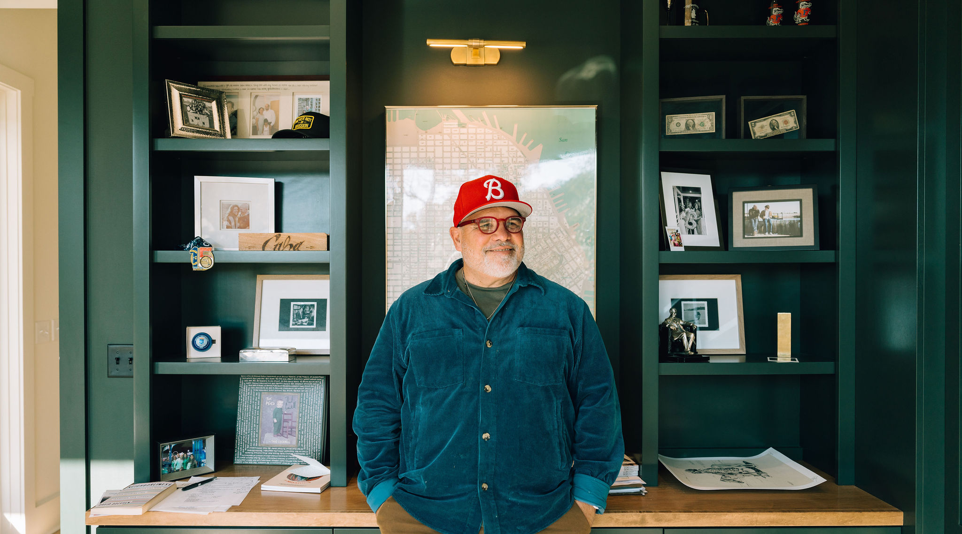

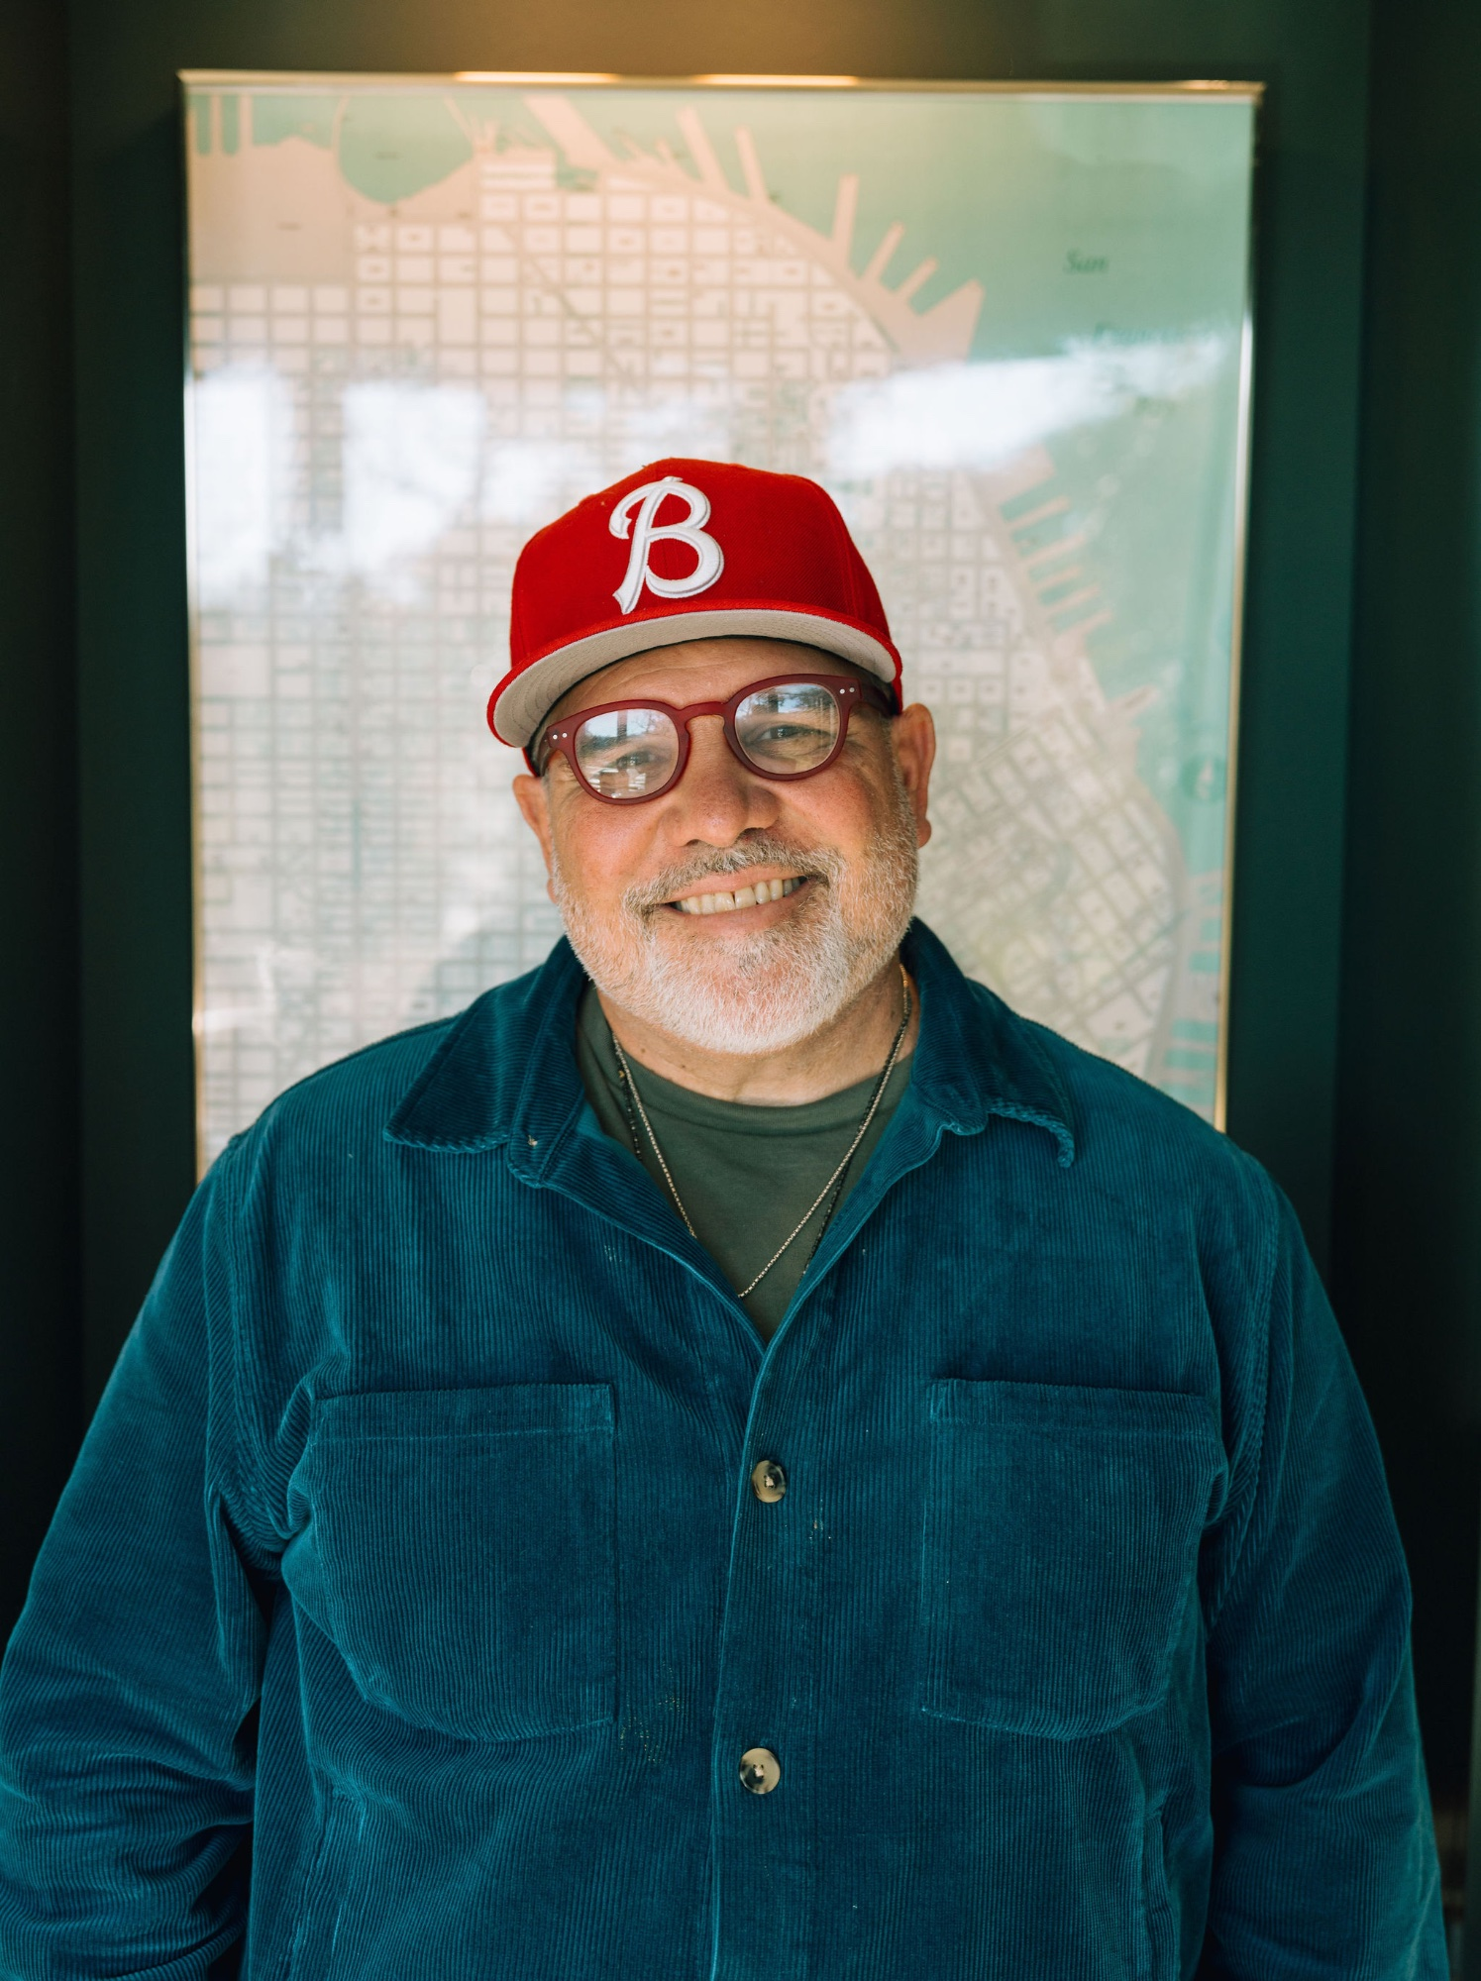 | 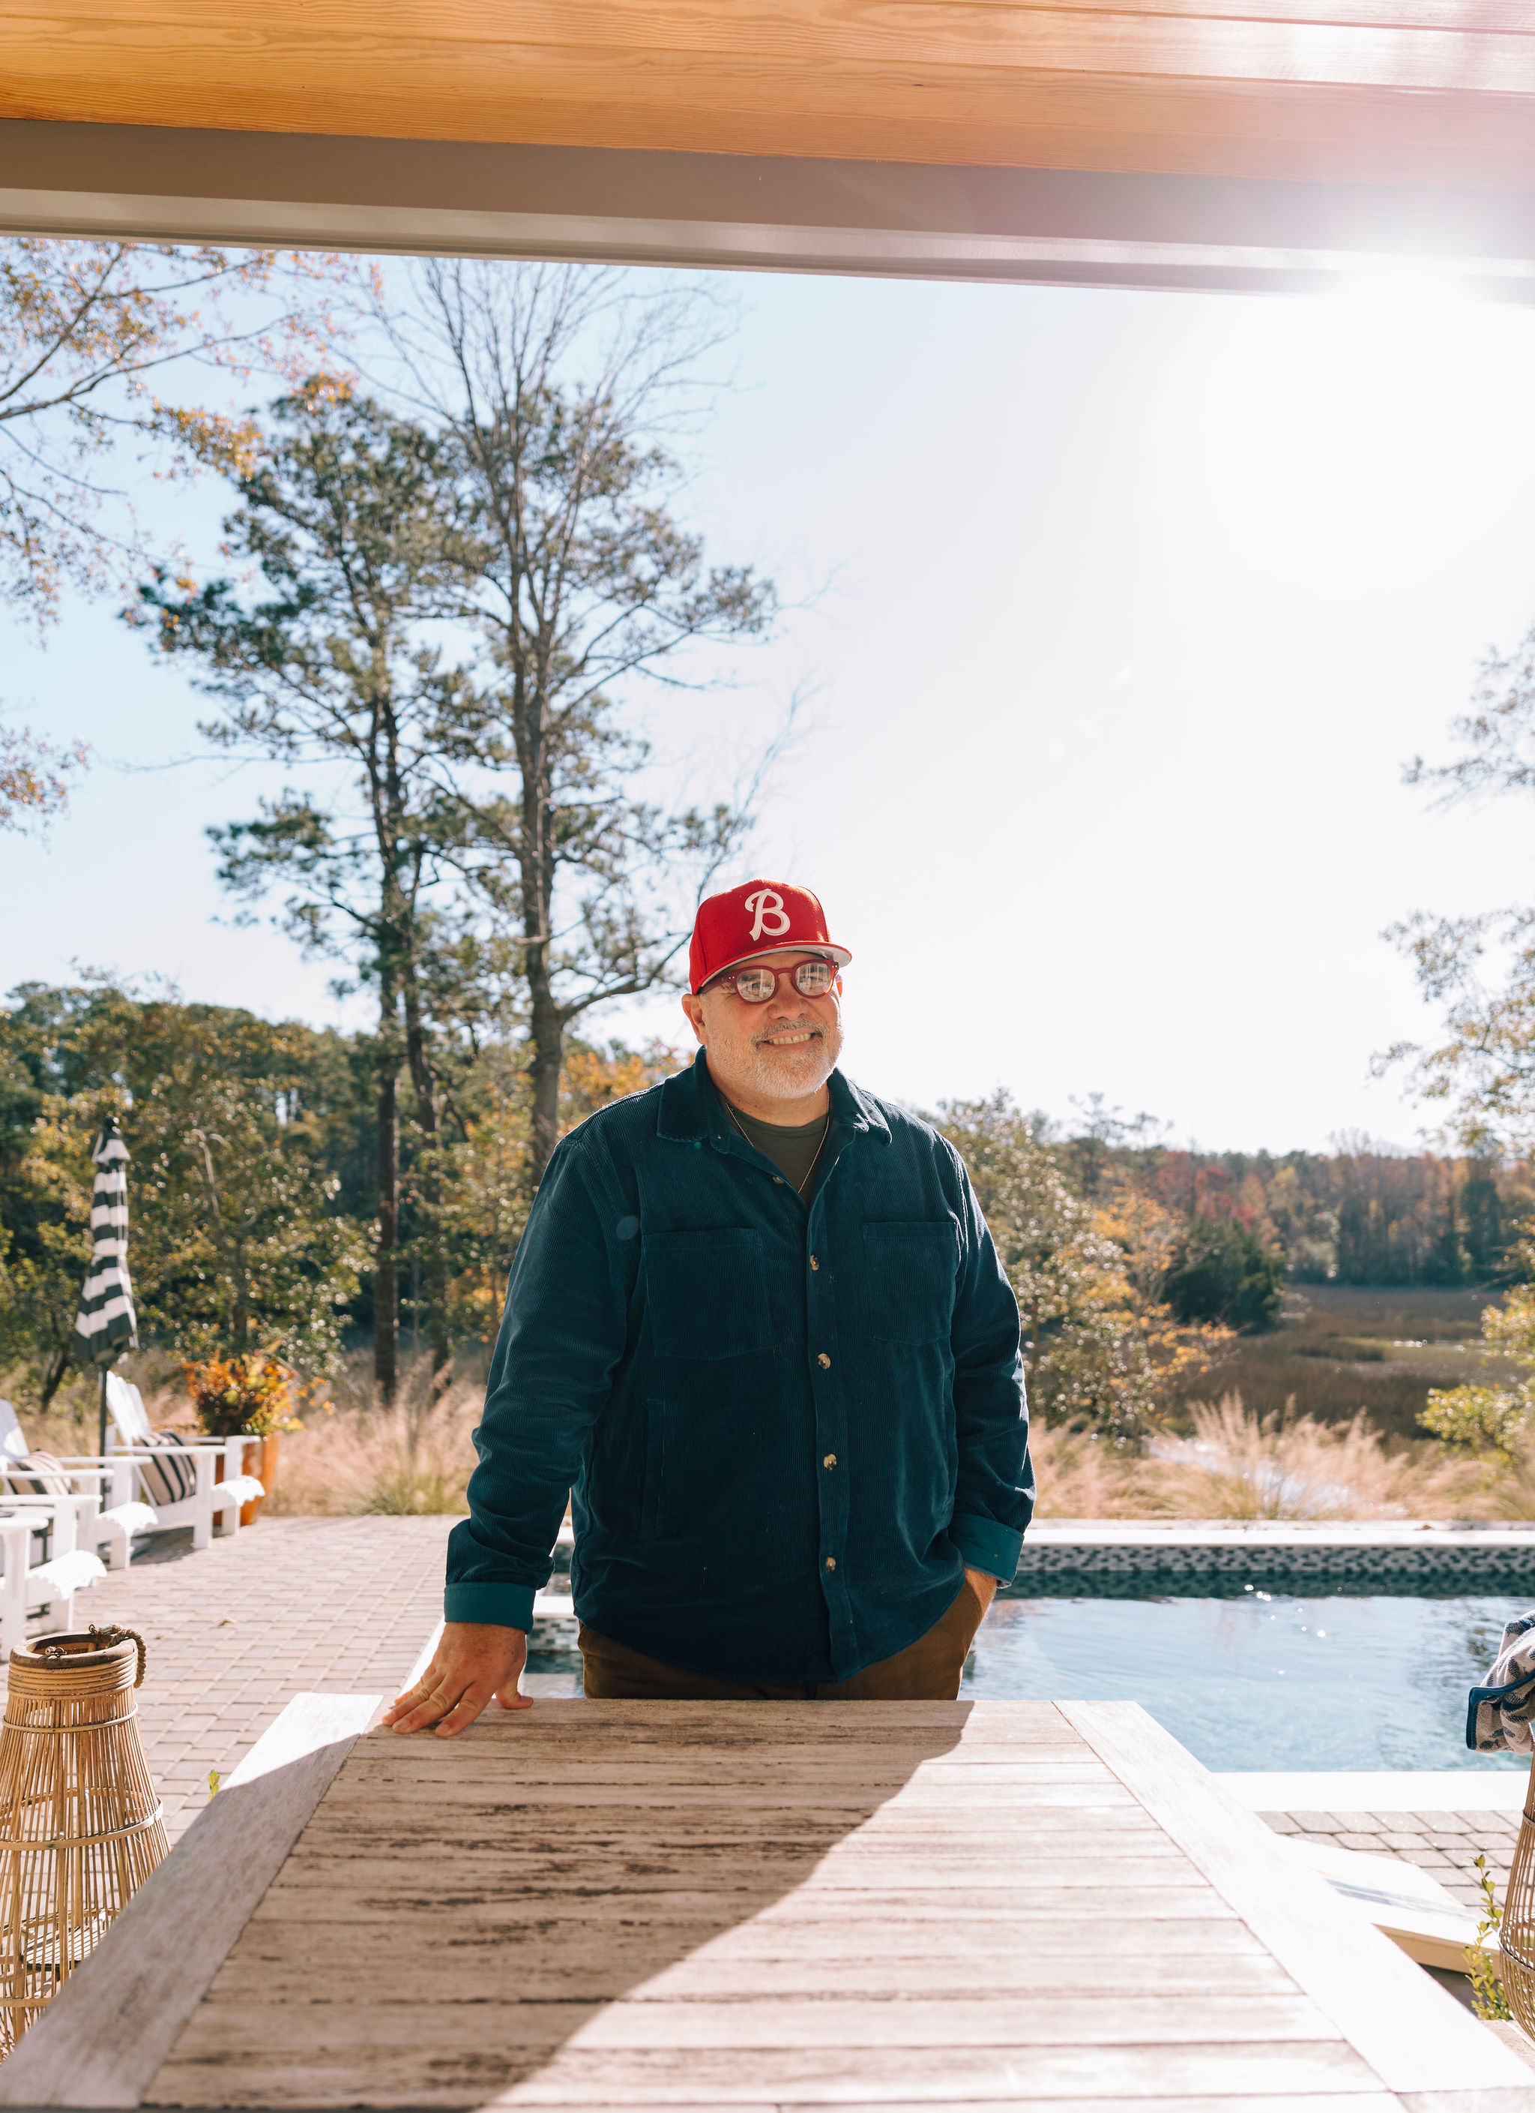

All photos © BC Leadership Co. Please credit photographer when required. For high-resolution files, contact bc@bcleadershipco.com.

Let’s Build Something Together
———————

Brek Cockrell
Founder & CEO, BC Leadership Co.

Email: bc@bcleadershipco.com
Phone: 716-310-2210
Website: bcleadershipco.com
Address: 39 Beatrice Ave, Buffalo, NY 14207

[Insert social media handles here]

“Trust over suspicion. Curiosity over certainty. Empathy over transaction.”
— Brek Cockrell

