Sharon Wagner, Founder of Momentum Leadership
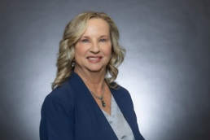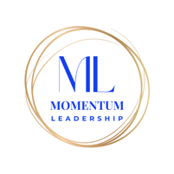

Sharon Wagner is a leadership keynote speaker, trainer, and coach who values dedication, service and excellence. She has 30+ years of leadership experience working for companies such as United Technologies, Northrop Grumman and a retired Army Officer and decorated combat veteran. Sharon brings unique perspectives gained from her experience to organizations by empowering them to unleash the untapped potential of their employees. She has a Masters of Business Administration (MBA) and is a certified Program Management Profession (PMP).
Additionally, Sharon is currently in the Morgan Hill Rotary Club, Chamber of Commerce and Leadership Morgan Hill.

