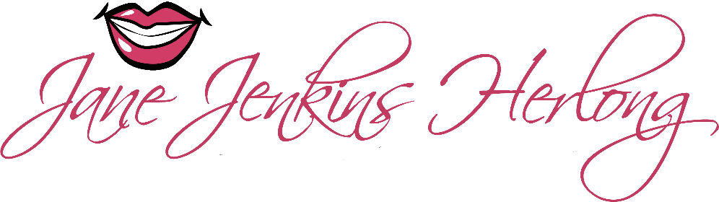
From farm fields to fame, Jane Jenkins Herlong is a Sirius XM Humorist and international best-selling author. Alongside Jeff Foxworthy, Ray Romano, and Jerry Seinfeld, her comedy is known far and wide.
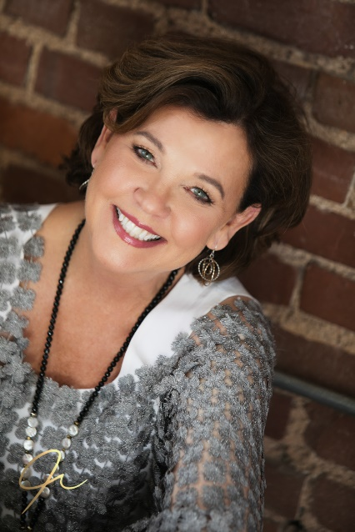
Not just a funny lady, Jane is also an award-winning author. She's churned out five award-winning books, each one more Southern-fried than the last. Her latest gem, "Sweet Tea Secrets from the Deep-Fried South," is on the shelves of Cracker Barrel nationwide and is being optioned for an upcoming film.
In speaking, Jane holds a place in the Speaker Hall of Fame, next to Ronald Reagan and the late General Colin L. Powell. She also earned the title of Certified Speaking Professional and recently was inducted into the Legends of Speaking in Washington D.C.
Jane faced her share of "You can't do thats" in her life, thanks to the dyslexic label stamped on her early on. But she just laughed, probably snorted, and transformed every "NO" into a "NEXT." You see, Jane believes that humor is the WD-40 of life—it makes everything run more smoothly. Jane shows crowds how to wrestle stress to the ground, and then high-five it out the door—all with a grin and a "watch me" attitude.
Her vocal and humor talents earned her features on Sirius XM, Pandora, Spotify, and Amazon. She speaks in four languages: English, Southern, Northern, and Lowcountry Gullah (gul-la).
Jane journeyed from the rows of her family’s Lowcountry tomato farm to the runway of the Miss America Pageant and then to Radio City Music Hall. She finished college with top honors and attended graduate school. Her message helps people change "NOs" into "NEXTs," one laugh at a time.
Whether sharing wisdom or humor, Jane Jenkins Herlong is an act you won't want to miss.

