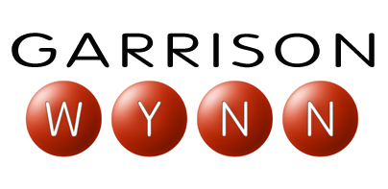
customization process

Garrison Wynn customizes each keynote program using research and pre-program planning for your event. From discussions with your superstars to surveying the top performers in your field, this process helps separate the so-called “good ideas” from what is actually working in your industry.
The keynote customization process:
- After the contract is signed and the date set, an event coordinator will send you a pre-program questionnaire that you will return to us before the conference call. The questionnaire will provide us information on the specifics of your event and general information to get our office familiar with your organization.
- Together we determine if it would be beneficial for our office to contact and interview key people in your industry or organization.
- A conference call is arranged between Garrison, the meeting planner and key decision makers to go over the questionnaire and discuss the content, mood and outcomes for the keynote presentation. Issues regarding your industry and the message you want your people to walk away with will be discussed in depth.
- Together we determine if we will use any of our assessment or benchmarking tools.
- Finally, Garrison and his staff will conduct their own extensive research into what the top people in your industry are doing that make them so great.

* This process is adaptable to the needs of each client.
Experience has shown us that with thorough preprogram planning coupled with our own research results, Garrison will deliver a "perfect fit" keynote to your group blending humor, content and a message that leaves your group feeling exactly how you intended.

