Neal Petersen’s AV Rider
A/V and room requirements for Neal Petersen
Lavaliere / Countryman Microphone
A wireless lavaliere is needed. Countryman system is preferred
Microphone for Introduction
The person who introduces Neal will need a separate microphone.
Platform
Please provide an elevated stage and adequate lighting so audience members can see Neal clearly. He needs a minimum of 12 feet in stage length and 6 feet in depth, with the stairs center stage (for quick audience access). There must be no arms on stairs as Neal will enter the audience during keynote. If hotel insists that they only provide stairs with railing, then the platform height should not exceed 12 inches.
Equipment on Platform
Neal will need a small table, chest high, (high boy) to hold his treasure chest on the platform with a cream or ivory colored linen drape and a sturdy banquet chair that he can stand on briefly with no sides. Please provide two bottles of water at room temperature for the show placed on the stage, hidden for easy access.
Show Computer with audio
The client will provide a computer that is capable of running Microsoft Power Point as Neal will bring his power-point presentation on a thumb drive. The computer must integrate with the video projection system, and plug into the audio system. The person introducing Neal will show a 90 second intro video and Neal shows a 2nd video during his presentation which is four minutes in length – about 45 minute in. Make sure it is plugged into the house system and is clearly audible. An operator for the A/V equipment is required.
Screen
Please make sure that the screen is large enough for everyone in the audience to see. If you do not have rear projection, please place the screen off to the side of the stage so the projector does not block the view of the audience. Another option (for groups no larger than 150) is to place two large televisions on either side of the stage.
Lighting
When the two videos are being shown, the house lights need to be dimmed. Please have lighting controls at the tech desk and if not, someone to operate the lights to pre-determined levels. Please ensure that Neal is properly lit on the stage, without washing out the video screens. Particularly when he stands on his chair, so his head is not cast in shadow. If necessary, use a separate lighting tree for the stage. Also, when possible and optional, in conjunction with the thunder audio clip, we use strobe lighting to create the effect of lightning.
Audience Seating
Neal requests that the audience be seated as close to the stage as possible. No empty seats in first row. Theater style is preferred, with a center aisle. Any format is fine provided there is a center row so that Neal can access the audience from stage center. If Neal is speaking following a meal, please make sure that the meal servers are not picking up dishes or pouring coffee during his presentation. This can be distracting for the audience.
Fog Machine
In large productions, creating fog on the platform for special effects is optional. Should we use this, the F-150 or two F-100 fog machines is desired. Client / Production Company will need to obtain the fog machines and the necessary permissions for the show and rehearsal to use this. A fire marshal may need to be present, during rehearsal and show.
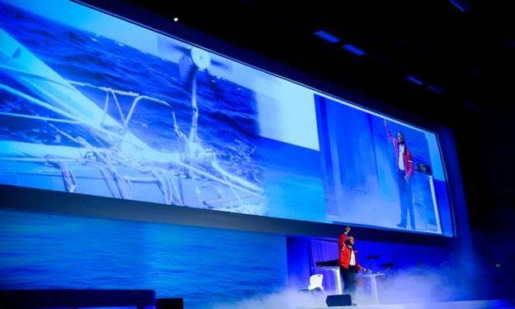
Imag shows
When doing Imag shows, there are three areas in the audience that needs to be lit for when Neal leaves the stage lit area. This will be decided during rehearsal and discussed on conference call. Please inform Neal’s office as soon as you know that this will be an Imag show, so that additional planning can be made. For Imag shows, rehearsal will require all show staff on headsets, and plan on an hour to get them up to speed. Images will need to be loaded in prior to rehearsal so as to not take up rehearsal time.
Conference Call is requested prior to event with main person responsible for overall AV to go over the technical side of the keynote. Typically this is done two weeks before the show date based on all parties’ availability.
Rehearsal
Everybody involved in producing and executing Neal’s show needs to be at rehearsal, which includes camera operators for Imag shows. Please make sure only those needed for rehearsal or invited attend. At least one hour should be allotted for rehearsal. Rehearsal needs to be done well enough in advance in case anything needs to be re-arranged. Please plan accordingly so that guests do not arrive during Neal’s rehearsal – doors should remain closed. Neal would like an opportunity to briefly meet the person who will be introducing him – prior to the introduction, rehearsal is a good option.
Meeting Planners
Please communicate with us asap whether or not Imag will be used. We also need to know if we will be using fog, lightning, Neal’s preferred show for larger audiences.
Questions?
If you have questions regarding Neal’s audio-video needs or the room set-up, please let us know.

