Guest Speaker Caroline Pethick
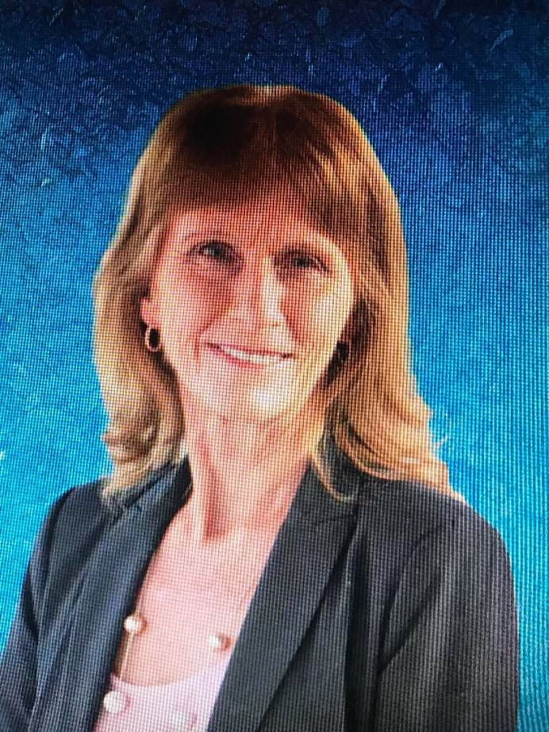
We were very fortunate to welcome Caroline Pethick, retired Police Officer and author, as our guest speaker for November. She has written a memoir called “To Hell and Back” which details her career in the Victoria Police Force. Caroline spoke with sincerity and openness as she described her almost 30 years of service in the police force, working in an environment which was overwhelmingly male dominated and patriarchal in structure. She is clearly an incredibly courageous and resilient person who is now dedicated to changing outdated attitudes towards women in the workplace and promoting safer work cultures.

Caroline’s story resonated with many in the room, who have themselves experienced bullying and harassment at some time in their lives. Caroline’s poignant and impassioned story telling meant that the hour she spoke went by very quickly. Her message of optimism and challenging yourself despite the hurdles you encounter was quite inspirational.

