Making Your Virtual Event an Experience to Remember
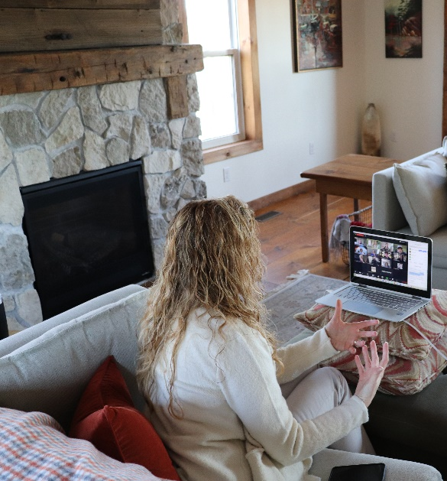
You are on good hands! Sarah has delivered close to 100 webinars, presentations and panel discussions in various virtual platforms for groups of between 10 and 250. (She loves video so much she uses it for all her coaching calls, interviewing of audience members for speaking research, and meetings with her remote team.)
Virtual Platforms Sarah Has Spoken on:
- Zoom – Meetings and Webinar
- GoToWebinars
- WebEx
- Google Hangouts
- BeLive
- Skype for Business
- Facebook & Instagram Live
See Sarah in action on virtual here or her YouTube Channel.
How Sarah Creates a Virtual Experience
Sarah uses a range of tools in every session to keep energy flowing and momentum growing!
- Breakouts with key points posted in Chat
- Polling before presenting information
- Raising hands to encourage feedback throughout
- Encouraging “Snap if you agree” (if the participants are on video)
- Sharing screen and annotating to emphasize points
- Q&A discussion (Sarah especially loves to bring people on live to ask their question)
- Features like “Sli.do” to build interactive world cloud
- Directing participants to share resources in Chat with links in chat
- Encouraging reflection during session and post in chat
- Closing out session with everyone posting one next step
There are new tools all the time; Sarah would love to experiment with your ideas and latest innovations!

