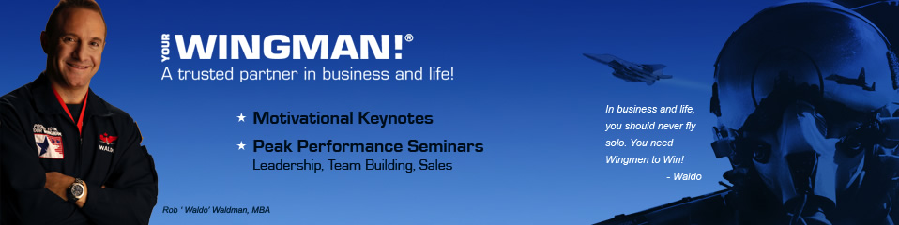
NEVER FLY SOLO!®
Lead with Courage, Build Trusting Partnerships, and
Reach New Heights in Business
Flying solo? You might think so. But take a good look around. You have support staff and managers. You have directors, suppliers, and partners. And you have colleagues and significant others. Today in our super charged, highly competitive world of constant change, those who build trust and work as a team will dodge the missiles of adversity and win. By committing yourself to excellence and placing your trust in those around you, you can overcome obstacles, adapt to change, and break performance barriers during adverse times. By placing trust in your wingmen and by being a wingman to others, there is no mission you can't complete!
Lt. Col. (ret.) Rob "Waldo" Waldman, The Wingman, overcame a lifelong battle with claustrophobia and a fear of heights to become a combat decorated Air Force fighter pilot and highly successful businessman, entrepreneur, and New York Times bestselling author. His motto is Winners Never Fly Solo! Through captivating, interactive stories, and high-energy video, you’ll learn tools and tactics to succeed in highly competitive, constantly changing, and demanding environments.
Discover how to commit yourself to excellence, prepare diligently for every mission; and collaborate with your team with trust, courage and mutual support. Be inspired to take to the skies knowing that you have wingmen to help you face challenge and change with confidence while maximizing your potential in all aspects of your life.
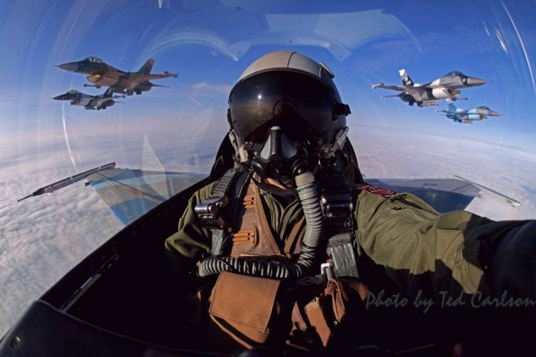
Waldo’s clients include Marriott, Allstate, Oppenheimer, Merck, Verizon Wireless, UPS, Hewlett-Packard, Siemens, and dozens of national associations. A Certified Speaking Professional (CSP) and an inductee into the Speaker Hall of Fame, he is the author of the New York Times and Wall Street Journal bestseller Never Fly Solo (McGraw-Hill) and has been featured on Fox News, CNN, CNBC, The Harvard Business Review, and SUCCESS Magazine. To purchase his virtual leadership training or to hire Waldo for your next corporate or association meeting, please contact one of his agents or speaker bureau representatives.
NEVER FLY SOLO!®
Lead with Courage, Build Trusting Partnerships, and
Reach New Heights in Business
Lt. Col Rob “Waldo” Waldman, Your Wingman®

MISSION OVERVIEW

Wingman®- A Trusted Partner in Business & Life

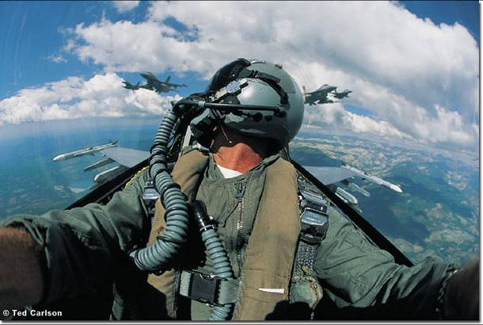
Critical Traits of Successful Leaders:

- Passionate about Excellence
- Prepares relentlessly
- Team Player
- Courageous
- Service focused

Key Wingtips and Phrases
PUSH IT UP!® 100% Focus, Energy, & Commitment
COMMITMENT: “Attitude in Action”
WIN: WORK IT NOW!
FEAR: Focus Energy, Accept Responsibility
CHAIR FLY – Visualize and rehearse every business mission. Plan for contingencies
CHECK SIX – Cross check your vulnerable position and monitor your wingmen’s blind spots.
BREAK RIGHT! Give and receive mission critical feedback.
WALK THE FLIGHT LINE – Appreciate your wingmen and walk in their shoes.
MAYDAY, MAYDAY! The three most important words in life are I NEED HELP!
WINGGIVER - A wingman who lends a wing to help someone overcome an obstacle

“What keeps you up at night isn’t as important as what gets you out of bed.” Waldo
“Lose Sight, Lose Fight!” U.S. Air Force
“The More You Sweat in Peace, the Less You Bleed in Battle!” unknown
“Prepare for the Worst, but Expect the Best.” Waldo
“Think outside the cockpit.” Waldo
“Wingmen Never ‘Wing it’!” Waldo
“Survivors focus on the competition. Winners focus on the customer.” Waldo
“Fear un-faced leads to doubt, and doubt destroys the winning spirit.” Waldo
“Never sell by the seat of your pants.” Waldo
“Your customer rewards your performance, not your attitude.” Waldo
The Four Commitments to Becoming a Wingman

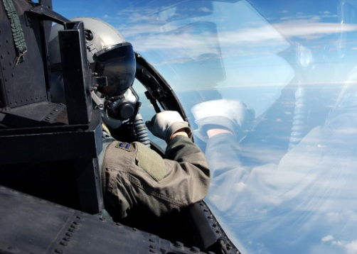
- COMMITMENT TO EXCELLENCE
  - Passion, focus & belief in the mission drive success
  - Push it up! = 100% commitment and effort despite the missiles of change and adversity
  - Be willing to stretch yourself
  - Complacency kills relationships, reputation & business
  - Lead by example…You set the tone!
  - “I Have the Aircraft” – Be fully accountable for results

- COMMITMENT TO THE MISSION
  - Be Mission Ready! Be Confident in your skills
  - Winners never lead or sell by the “seat of their pants"
  - Attitude + Action determines Altitude
  - Prepare relentlessly and create a flight plan before you strap into your jet
    - Know your objective, clients, competition, partners and product
    - Leverage technology and corporate assets
    - Chair Fly – Mission-rehearse and visualize the ‘what-ifs?”
    - Plan for contingencies – How will you handle objections/change?
  - Build trust by asking the right questions and listening to your clients & prospects.
  - Use quick reference checklists to assist in handling contingencies.

- COMMITMENT TO THE TEAM
  - Winners Never Fly Solo – they build trust through mutual support and collaborate
  - Leaders Lift: Encourage your wingmen and customers in the face of adversity.
  - Check Six: Mutual support = Improved perspective: cross check your most vulnerable position: behind you. Watch for threats and monitor your wingmen.
  - Break Right! Communication is mission critical. Be willing to call out threats to your wingmen and be open to feedback. Take action and trust your co-workers.
  - Mission Debrief – remove rank and name tags and share the brutal truth.
  - Walk the Flight Line: Appreciate your wingmen and the unsung heroes behind the scenes who get the job done. Get to know them as people first and employees second
  - Who are your wingmen? Who can you be a wingman for?
    - Marketing, customer service, finance, tech support, channel partners, IT, etc.

- COMMITMENT TO COURAGE
  - Winners take action despite their fear
  - Courage helps break performance barriers.
  - Growth involves stepping outside of your comfort zone and taking risks
  - “I need help” is the wingman’s call to action.
  - Fear turns into courage when you focus on your mission…your purpose.
    - Who/what are you fighting for? (I.e. clients, family, freedom, charity, etc.)
    - Find meaning in your mission – who are you serving? Who do you love?
  - “Lose Sight, Lose Fight!” – Never lose sight of your customer, your purpose, your wingmen, and what you really care about.
  - Be a “Wing-Giver” – the type of wingman others come to for help.
  - “Love Lifts, Fear Drags” - Let others know with you on their wing, they cannot fail.

