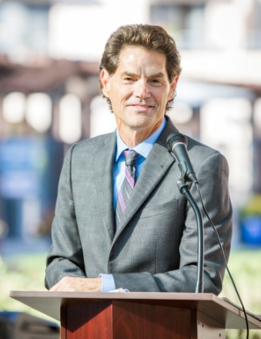

Speaker
Trainer & Coach
Jerry Bridge is a nationally recognized motivational speaker, humorist and author. Jerry is well known for turning complex, topics into fun, engaging thought provoking programs. In the past 25 years Jerry has presented inspiring keynotes and content rich workshops for tens of thousands of business executives, managers and administrative staff. Jerry is best known for his ability to help people reduce stress build teamwork and improve performance. His passion is to lead inspiring, motivating programs that empower people and have lots of fun in the process.

Jerry compliments each and every platform speech with in depth teaching and coaching.
He believes that inspiration and motivation, while necessary, may not always get you or your team to the goal line. A seasoned veteran, Jerry integrates over 25 years of specialized training and development with Landmark Education Corporation; a leader and innovator in the field of transformational education. Jerry is a master coach; from sales to teamwork to fitness and well being, attendee’s complete his programs with practical tools, practices and no nonsense take aways.

Author

Personal
Great speakers are also passionate about writing and lifelong learning. Jerry follows form with his numerous books and articles. Jerry’s books include; “Who Cares? The give and take of Family Caregiving.”

Jerry is a baby boomer from Baltimore. He’s never lost his fondness for his hometown teams, blue crabs and Maryland hospitality. Jerry has travelled the world running marathons, raising money and resources for ending hunger. In 1989 he met and married a woman from San Diego on the way to Moscow to run an international peace marathon. Jerry moved shortly thereafter and became a father to his Son Danny. Jerry is a drummer, knows his way around a kitchen, and occasionally performs standup comedy.


Guaranteed!
Your members will be inspired, entertained and focused on what matters most-at work and in life!

