February 27, 2014

Why the Growth of Black Businesses is Skyrocketing

Black entrepreneurs have seen their businesses grow in leaps and bounds over the decades. But what barriers still remain for their success?

Alfred Edmond Jr.
Relationship Education Proponent/Coach, A2Z Personal Growth Enterprises - GrownZone.com

Each February, we celebrate Black History Month, an annual recognition of the heritage and contributions of black Americans to the nation and the world. The most prominently celebrated tend to be African-American achievement in the arts, sports, politics, education and civil rights, and rightfully so. But we would be remiss if we overlooked the accomplishments of African-American entrepreneurs during Black History Month, especially given the progress made over the past several decades.
For a quick snapshot of that progress, let’s take a look at the Black Enterprise 100s, our annual listing of America’s largest black-owned businesses. First published in 1973, the combined annual revenues of the companies on that list was $492 million (an inflation-adjusted $2.6 billion today). Fast forward to our most recent BE 100s report and you'll find that the 100 largest industrial/service companies generated combined annual revenues of $19.1 billion. This does not include an additional $7.2 billion in annual revenues generated by a separate list of the 60 largest auto dealerships, nor does it include the revenues of companies on additional rankings of the largest black-owned advertising agencies, banks, asset management companies, private-equity firms and investment banks. The nation’s largest black-owned company, World Wide Technology Inc., led by CEO David L. Steward, reported $5 billion in revenues—more than 10 times that of the companies on the original “Top 100” list combined.

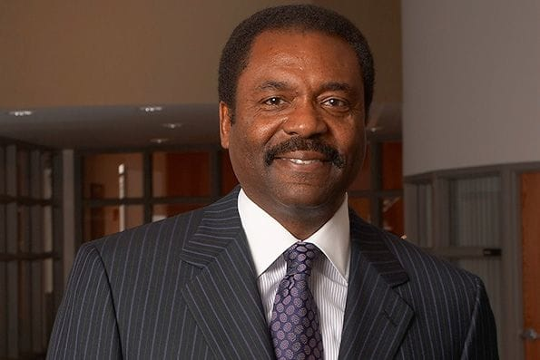

Progress in the growth of black entrepreneurship is not limited to the largest U.S. companies. In 1972, the U.S. Census Bureau recorded 195,000 black-owned firms. By 2007 (the most recent census figures available), that number had grown to 1.9 million, of which 6 percent were employer firms generating annual revenues of nearly $1 million each—about the size of the smallest companies on our original Top 100 list. For most of the last two decades, in particular, the growth of black-owned enterprises has outpaced that of mainstream companies.
ADVERTISEMENT
Product Solution

Say Yes To Your Company's Best Ideas
Follow your passion and we'll follow your lead, with Cards and funding to help you grow your business and your rewards. Terms Apply.

Turning Points
It’s clear that over the past 40 years, black businesses have grown more rapidly and into a wider array of industries, from tech and food services to engineering and financial services, than at any previous time in American history. This is due in part to barriers to capital, corporate contracts and government contracts being lowered or eliminated by anti-discrimination legislation and equal opportunity efforts as a result of the triumphs of the 1960s Civil Rights Movement, and the subsequent election of African-American mayors in major cities in the 1970 and 1980s (most notably, Mayor Maynard H. Jackson, Jr. in Atlanta).
Concurrently, and perhaps more significantly, was the ability of African-American entrepreneurs to move beyond marketing to only black consumers, as a result of legal and de facto segregation, to eventually compete in national and even international markets. Through the 1980s, the nation’s largest black-owned businesses were led by companies such as Berry Gordy’s Motown record company in Detroit and John H. Johnson’s Johnson Publishing Company (best known for Ebony and Jet magazines) in Chicago, which catered primarily to black Americans. Today, none of the 10 largest BE 100s companies target African-Americans or any specific ethnic market. The watershed event in this transition: the landmark $985 million acquisition of Beatrice International Foods by Reginald F. Lewis in 1987. The deal created America’s first black-owned company with more than $1 billion in revenues, while serving customers who were not only not African-American, but not American at all—nearly all of its businesses operated in Europe.

Breaking Down Barriers
What is the state of black entrepreneurship today, and what must happen for it to continue to grow and diversify nationally, as well as globally? The challenges are many, and include those that all entrepreneurs face. However, the following factors are critical for black entrepreneurs to continue to break barriers and compete:
- Entrepreneurial education. Once upon a time, rugged individualism, intrepid determination and subject matter expertise—in food service, publishing or hair-care products manufacturing—was enough to start and grow a significant business. Today, African-American business owners must be students and ultimately masters of entrepreneurship itself, including developing a capacity for raising capital, financial management, strategic planning, brand positioning, mergers and acquisitions and other nuts and bolts of growth beyond mom-and-pop status.
- The need to achieve scale. It’s relatively easy to start a business, especially given the popularity of entrepreneurship as a viable and legitimate career objective among younger Americans, and young black Americans in particular. The challenge today for black-owned businesses is achieving the scale necessary to compete, whether for government contracts or to do business with large multinational corporations.
- Greater access to financing. Despite the progress made by black entrepreneurs over the past 20 years in particular, very few have been able to gain access to the predominantly white private equity, angel investor and venture capital communities that have driven investment in the innovative new companies and industries currently fueling our economy, especially in the technology space. A growing number of programs and initiatives are working to better prepare black entrepreneurs to establish relationships within those communities, and to do a better job of attracting interest and competing for investment. Perhaps most notable among these is the NewMe Accelerator brought to the national consciousness by CNN's "Black In America 4: The Promised Land—Silicon Valley."
The entrepreneurial spirit among African-Americans is more robust than ever, inspired by role models ranging from Oprah Winfrey and Magic Johnson to Daymond John of Shark Tank reality TV fame and hip hop icon Russell Simmons. I personally look forward to the emergence of a new generation of African-American entrepreneurs, with even greater accomplishments to celebrate during the Black History Months to come.

