My 100 miler. I learned willpower is not unlimited.
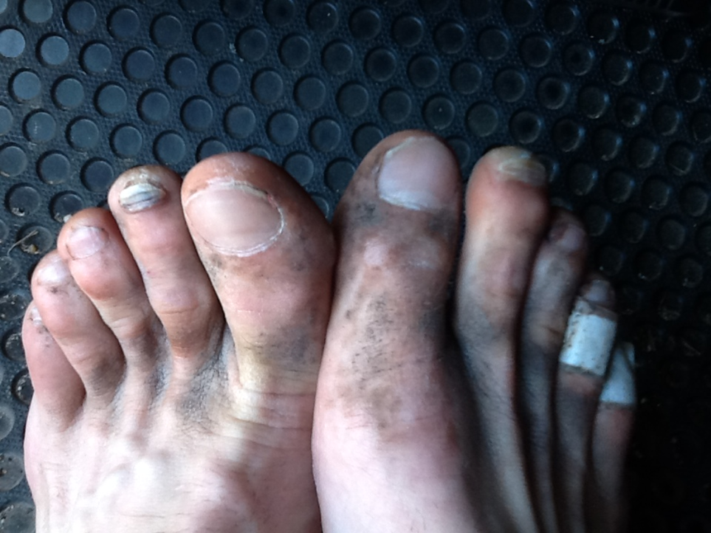
February 4th, I experienced what I still consider the most difficult mental and physical, combined all into one day achievement. On this day, I was lined up very early on a Saturday morning alongside 406 other competitors, waiting, anticipating the gun to go off, which would mark the beginning of the 100 mile run race these runners were about to take on. Competitors had 29 hours to complete the fairly flat, but rigorous, arduous and demanding course. The course was dotted with large pine trees as well as all sorts of other deciduous trees which offered much shade and beautiful topography. Alarming to race competitors, as well as the spotty placed spectators, was this year’s lack of rainfall which had fueled pronated and exposed tree roots everywhere along the course. This offered additional obstacles for runners to deal with along the 100 mile trail course.
Adding salt to the raw thought of trying to simply run 100 miles all in one-day, was that on this day, February 4th, it was pouring rain. The rain had begun many hours earlier. I had not been able to sleep much the past 12 hours and had watched from the window of my hotel as the rain began to fall, got heavier and just kept coming. By now the race course was soggy wet, not to mention the starting line, 5 inches under water and mud, which I and his fellow competitors stood in waiting for the gun to sound off.
I had prepared well for this race. My body was ready. My mind was ready. Competing in this race had been just one of the things on my long list of things to do before I died. Once thought not possible by me, not within my willpower tool kit, I stood ready, prepared and anticipating this willpower challenge.
As I stood at the starting line, I took in the smells of the forest surroundings, pitch and pines, flowers, grasses and forest air, the anticipation as well as anxiety in the bloating early morning air. 406 people were all about to attempt an extremely difficult journey, both for the body and the mind.
A hundred miles on foot. Seem far? Not really, a person can drive a car at 75 MPH for 2 hours and reach a hundred miles. Growing up my family frequently took the 100 mile journey in a car to grandma’s house. My father and mother would pile in the car drive south from our home. Two hours later, after passing the stinky pulp and paper plants, fields of all sorts of different Oregonian agriculture’s, wild black berries along the roadsides and rickety old bridges; we would finally arrive to Cottage Grove, Oregon, the little town where Grandma lived.
Often after Dad and Mom announced the family was headed to grandma’s house, I and his siblings would begin the habitual whine and complain sessions. Waling, moaning and groaning, complaining with such laments as “What am I going to do for 2 hours in the car?” “I don’t want to read.” “I don’t want to stare out the window.” “I don’t want to inhale the fart smell of the pulp and paper plants,” the pulp and paper plant smell being a bonus of driving to grandma’s, other than that…”Why are we going so far?” “Why can’t grandma come visit us?”
My brother and I, stuck in the back seat of the car would often get talking about how cool it would be to walk or ride their bikes from their house to Grandma’s. Although it was only 2 hours, I and his brother always landed on the same conclusion, 100 miles is a stinkin far journey.
Just in case you wondered, running or driving 100 miles is synonymous with taking 528,000 steps. Most of us feel good about taking 10,000 steps per day as recorded on our Fitbits. Now add 518,000 more steps. Oh, and if you are racing on foot 100 miles, you have a maximum of 29 hours to get it done.
Back to race day. I had chosen a race in February in Texas. I had thought, Texas, February, perfect time and location of the year to run. Shouldn’t be hot or cold or snow or wind or yuck. I had not counted on the unusual torrential downpour occurring on this race day. My little family and I had left the hotel room that morning at 5 am to the on-going torrential downpour. We arrived at race start location with just enough time to allow me to get all lubed up, jazzed up, fueled up, and stretched out. Still torrential downpour.
As the race gun went off, I surged with adrenaline, serotonin, oxytocin, dopamine and a wealth of other endorphins all mixed to generate a flood of excitement, anticipation and keenness in the execution of a plan to get this challenged achieved.

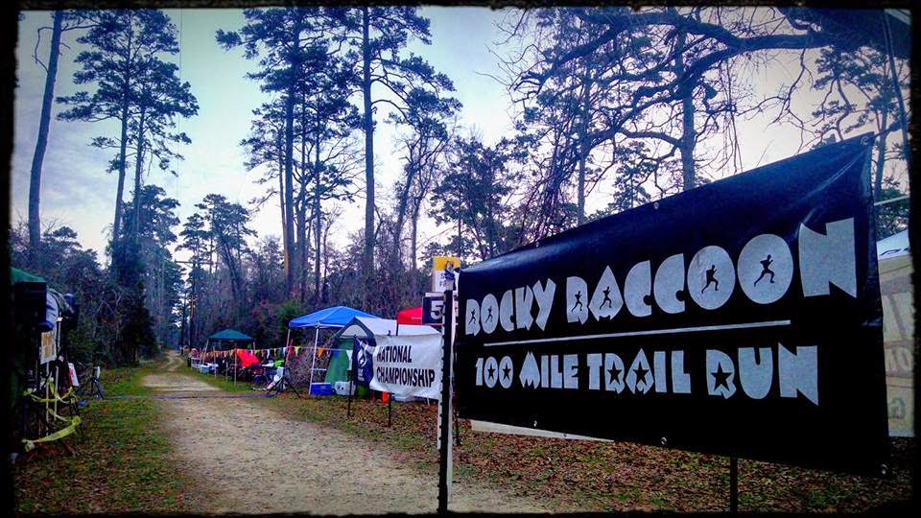
200 yards
As all 406 runners swarmed the narrow trail, congestion and race start juxtapose occurred. While it was not the frenzy of a typical 5K or Marathon race, pushing, shoving, and bumping into each other still was happening at today start. At 200 yards out I had all but lost his thwarting with the pouring rain and slop hole like conditions.
I was here, I was present, I was prepared, and I was on top of the world. At 1 mile out, the competitors hit a particularly muddy and wetted stretch of the course, many losing their feet and ankles in deep mud only to pull a foot out of the quagmire to find no shoe on feet. I was one of these unlucky people. In a moment of desperation, I spun around, one foot out and shoe lost in mud, while the other foot and shoe were still attached, I drove his hand right in the mud hole where shoe was last seen and pulled the shoe right out. In an almost ballet looking move I slid that shoe right back on and was back in the race.
I had had no practice or built any sort of habit for dealing with missing shoes in mud on the course. I had scarcely prepared to deal with the slippery, slidey and quicksand sort of trail that lay before me. However, the change of topography and Spartan like race conditions was thrilling for me. I also mentally registered the additional effort these race conditions were demanding, prematurely tapping willpower reservoirs he had not anticipated.
For the next 6 hours – it rained and rained and rained. Even with only 406 runners, the trail quickly became an absolutely slosh pit, with some unreal obstacles and course challenges. For the first couple miles, all 406 runners choked the trail, almost looking like a Tour de France peloton but with runners running into each other, stepping on others shoes, bumping, pushing, and rubbing. I chuckle thinking back about the physical appearance of the runners, after just a couple miles. We all looked like we were involved in a mud wrestling competition, not a 100 mile run race. This was crazy and yet absolutely thrilling. I was right where I wanted to be. Testing the limits of my known willpower. Testing the limits of the willpower reservoir I had been working on for months and frankly years, all leading up to this race, this day, this time, and this moment.
After several miles, the runners started to fan out along the trail and running became a little easier. The course was beautiful and fun. It’s so rewarding to run on trails with trees, foliage, and rolling evaluation changes. The course quickly snaked away from any sense of civilization and it was just me, the trail and nature out there.
Then, all of a sudden, with zero notice, I went down, face first in the mud. I hadn’t sufficiently cleared one of the numerous tree roots that spidered the path everywhere. This would prove to be a challenge thee entire 100 miles. There were deeply exposed tree roots everywhere lacing the trail. Runners at no time could afford to take their eyes off the trail, if a runner did, they risked getting snarled by an exposed tree root and risk going down. I would count more than a dozen times I would go down due to root snarls. Each fall coming unexpected and as the miles drug on and on, each fall got more painful. I would remember with pain as well as a sense of accomplishment that the 8 black toenails I sustained while running the course being primarily due to ramming into roots with my shoes and going down.
20 miles
I remembered somewhere in the first 20 miles of the race engaging a fellow runner in conversation. This runner had done this course before and acknowledged that he had never seen it so muddy and so root exposed. He hypostasized that the additional energy, stamina, leg raising and willpower required to dodge the exposed roots likely made their 100 miler more like 125 miles to complete. How damming a thought for me as I registered this theory and even felt an unduly amount of willpower juice drained by my psychological system as it recorded this unforeseen impediment. Still I pressed on, soaking in every ounce of this festival adventure.
The rain continued to make the trail a hirsute and slippery jumble, especially on downhill and uphill sections. Deep mud and water pits were the commonplace along the trail, water and mud now 3-8 inches deep in places. The mud caked to shoes adding weight and awkwardness to running forms. This was another contingency that I had not dually prepared for. The trail was narrow and tight, forcing the only choice to simply go straight through the mires of mud and standing water.
I enjoyed the serenity of the forest as he passed the 20 mile mark. He savored the fact that he, a kid from a no-where Oregon town was attempting an insane act for me, one that I had for the longest time only dreamed of doing. I could feel the runners high at 20 miles out, the euphoria of having taken the challenge, having decided several years before that I was going to do this, and now today, February 4th, I was out there. I had paid the price in training for months before in order to build the confidence level that was needed.
I also thought of my 3 young kids who were on the trail somewhere, hoping, believing, and wanting Dad to finish. They were proud of Dad, they having told many of their friends that their daddy was running this race. There was no way I was going to let them down and intended to live up to this challenge to finish. This unwritten sense of accountability would prove critical to my race finish. Also out on the course was my biggest fan, the woman who has been to nearly every single one of my races (and there had been a lot of the years). My wife had analyzed every mile of the course, and helped to strategize getting the job done.
40 miles
At 40 miles, I changed my soggy, completely wet and mud caked socks, hoping for a brief period of dry feet. This was an exercise of futility. It afforded dry feet for about 3 seconds. As I changed my socks out, I noticed I had already developed 2 huge blood blisters. I attempted to dry off my feet enough to put band aids and duct tape over the blisters. This didn’t work either. 100 yards after leaving the pit stop, I felt the band aids and duct tape sliding off and towards the toe of his shoe. I stopped briefly and tried again, this time doubling the duct tape to keep wetness and friction from occurring between my skin and sock. Yeah! Only 60 miles left with these conditions. Post-race, I was proud of the bloody blister mess that engulfed the bottoms and toes of his feet, but at 40 miles I was not happy. Wanting to preserve the memory, I had my wife thoroughly photograph my feet, proof that I was hell-bent on achieving my goal. It was insane, yet I vividly remember as I changed those wet socks and saw the blisters and the blood, my resolve was undaunted, I simply was not willing to not accomplish this goal.
I had trained months for this race, logging a running plan that consisted of Monday’s -8 miles, Tuesday – 15 miles, Wednesday – 6 miles, Thursday – rest, Friday – 40-60 miles, Saturday – 20-30 miles and rest on Sunday. I knew pain would come. I knew why pain came and learned to turn it into a game to win. I practiced, practiced and practiced in training – altering the elements of the training, and pushed my mind to deal with the challenges and obstacles that come with trying to achieve something difficult. I ended up facing a number of ailments, setbacks, injuries and blocks as I had prepared for this 100.
At certain times in the preparation process, I had faced swelling in his knees, ankles, gotten plantar fasciitis, hurt shoulders, shin splints, major quad pain, fevers, and extreme dizziness. I used the practice training runs and races of all lengths and distances short of 100 miles to experiment with mentally and physically moving past those challenges. I planned and practiced eating all kinds of foods on the long runs to insure I found the perfect mix of nutrition to keep my physiological body energized.
I practiced shoes and shorts and body glide and shirts and hats and gloves to insure I had removed these items from being obstacles in reaching the 100 miles. I practiced carrying water to get it just right and insured I consumed enough fluids to fight off lactic acid and stay hydrated. I tried first using my Nathan fuel belt that goes around your waist to pack liquids. But because of previous invasive surgeries to remove my appendix and gall bladder, I had surgery wounds which included a large scar, which created friction between the fuel belt and my scar forcing bloody sores every time.
So I gave that up the Nathan belt and went to a camelback. It was great, but it rubbed the skin off his shoulders. I was able to finally find a suitable camelback that solved my problems. On long training runs, I would pack up to 1.5 gallons of water on camelback, 15 or so GU’s in my tri top pocket, big bag of nuts, jerky and raisins, and eggs. It was heavy and awkward, but made me totally self-sufficient while out on practice runs in the dark, sometimes as far as 30 miles from home. To fit in practice runs, a full time job, family and other responsibilities, I would often leave home on a Friday night and run through the night to achieve his 40-60 miles. I’d return home the next day, rest for 12 hours and then go back out for another 20-30 miles to push and train my fatigued legs to go further in order to eventually complete 100 miles all in 1 day.
I had a number of mental exercises I implored on long runs at various times and I attribute these mental exercises as an invaluable key to having reached the 100 miles. I was a big fan of a guy named Stu Middleman who is arguably the most decorated ultra-marathon runner ever. I had taken Stu’s wisdom and worked hard to literally train my mind to not succumb to the pain.
I had been able to effectively consume my prearranged nutrition plan for the first 60 miles of the 100 mile course. This included one 100 calorie GU every 30 minutes, combined with a handful of nuts and a piece of jerky, 12 oz. of water, 2 salt tablets and 1 aspirin and a swig of flat Coke.
This strategy seemed to be working well; however, somewhere around 60 miles, as daylight started to fade and the sun set, my body began rejecting the food and nutrition I needed to keep the physiological system working. I could hardly down any nutrition without feeling really yucky and wanting to puke it up. Knowing well the dangers to the willpower reservoir of no replenishment, I gave up eating my solid food and switched to chicken soup at the aid stations as well as a swig of his flat Coke to keep nutrition coming. That’s all I could mentally make go down to attempt to replenish my physiology system.
60 miles
As I passed the 60 mile marker, darkness had set in. Although my body was hurting, I felt the dopamine again as I thought about running in the dark. I absolutely love running in the dark, all by himself. In training runs I often crave getting up at 2:30 am in the morning and heading out for a 42 mile run. I often keep my flashlight off and just ran under moonlight. I love the euphoric feeling of running in the dark, alone.
As I turned and saw the 60 mile marker, I also caught wind of my children. They had come to help pace me for a bit. They jumped on the course and the 4 of us ran together for several miles. Running together boosted my spirits. My kids truly helped dull my aching spirits. They told me stories and for those few miles, I forgot about much of my mental and physical pain. The kids dropped off at 3 miles and I headed alone into the pitch black forest. The physiological and willpower strain soon returned. The next 20 miles were a blur, painful and gut wrenching.
I was hurting, I was sore, yet I still vividly remember the thrill of running that trail in the complete black of night with only moonlight peeping occasionally through the trees high above. I kept my flashlight in hand ready to help avoid tripping over roots still covering the trail floor. By this time all of the runners were entirely spread out and there were long periods where I saw and heard no one. I was very grateful for the aid stations, some had volunteers standing by, some did not, but all of them provided food, hot chocolate and soup which I attempted to force down at every stop. Then back out into the darkness. It was heaven out there, yet sprinkled with hell having to deal with the fatigue and pain that coursed my body on every step.
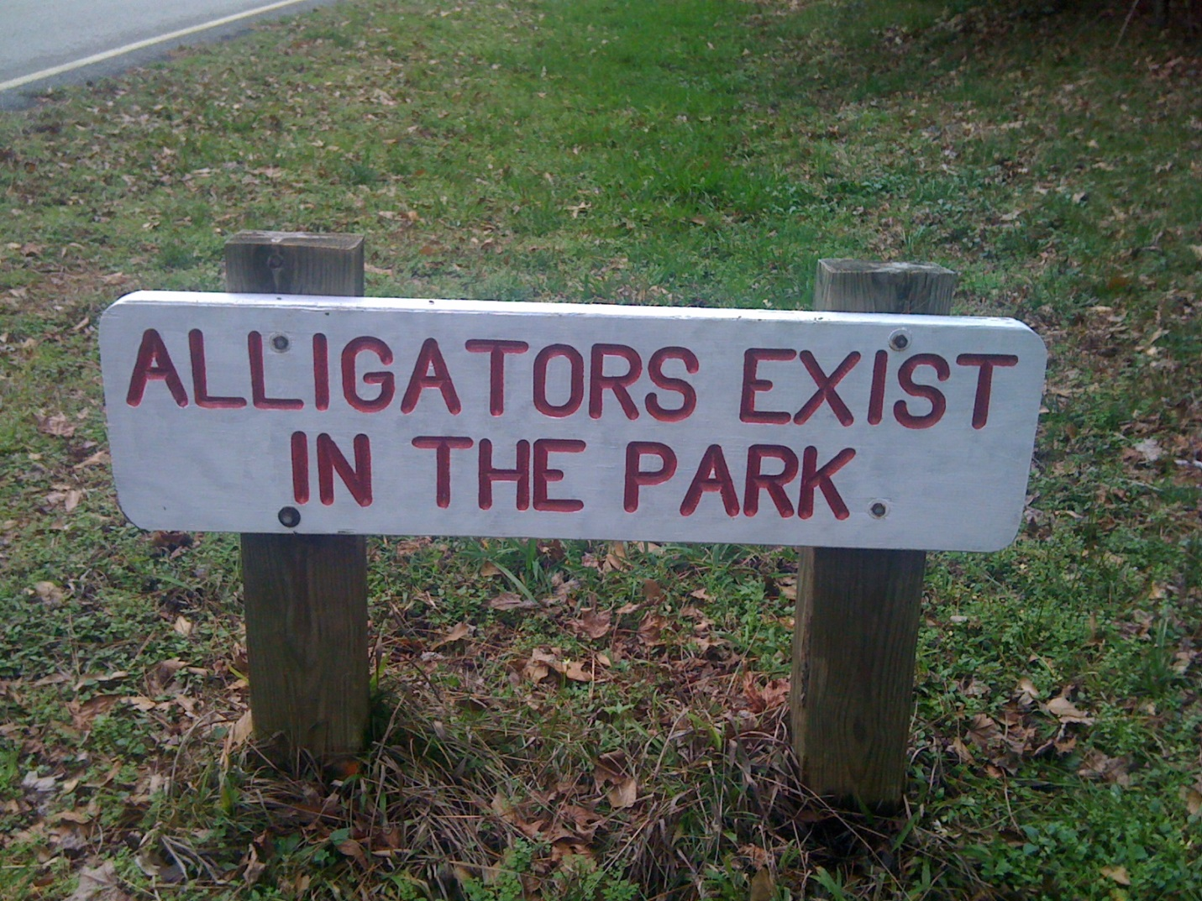
80 miles
As I hit 80 miles, it was about 1:30 am in the morning the next day. I had been on my wet feet for 19:50 hours straight. I saw my wife and kids waiting for me at 80 miles. What a joy. I asked for some icy hot for my seized up hamstrings and some flat coke to tame a turbulent stomach.
My race strategy also included listening to books on audible.com and when that was no longer tolerable, I switched to some rockin running tunes, all aimed at diverting my attention away from pain and more towards completion. I had been able to get through many hours of a good book on the 100 mile course, but then had switched to some of my favorite Good Charlotte and Duran Duran tunes. As I passed 80 miles, I was overtaken by such intense pain coursing my lactic acid filled muscles that I decided to turn off the iPod and simply focus on telling my brain to deceptively send extra fat I had on my body to places like my aching legs and upset stomach, as a pain reliever. It worked. It always worked. It took hard mental work when the body is hurting to keep this illusionary story going in my head. However it diverted energy, wasted on thinking about pain, towards a worthy project of reducing that discomfort and forcing it to override the physical pain.
Between 80 and 100 miles, hot chocolate, found at the aid stations turned out to be a magic solution for me. My stomach by this time was a frenzy of queasiness and wooziness. It took all I had to keep from throwing up. Traditionally flat Coke had done the trick to ease an upset stomach, but today it was not working. Hot chocolate was the ticket. Not sure why, but I was able to down a whole cup of chocolate at each aid station and it really helped calm my erupting stomach. Prior to the hot chocolate solution I felt like I was spending 95% of my mental fortitude telling my brain to send relief to my stomach to avoid throw-up. I also knew that if I started to throw up, it was over. It had become an all-consuming game to me; tell my brain to send relief to my stomach and arching legs. I used a literal visual analogy of scooping fat with a teaspoon from my waist where fat still resided and deposit that fat to my legs where it could be converted to energy. It helped.
With 20 miles left, I headed back into the darkness. At this point, I felt 110% dead, running on pure muscle and desire. I made the decision at that time that I would not fail. I headed back into the abyss and battled the next 6 hours to complete the last 20 miles. Those miles seemed like forever. Every step was painful.
90 miles
At 90 miles my right leg, especially my calf was completely seized up, something wasn’t right, but I pushed on. At 92, I winced every time I moved my right leg. But there was no way I was quitting; I would crawl if I had to. Amidst the almost indescribable pain I was feeling, I was able to experience a short psychological lift at the expense of others. At 92 miles, I began to pass other runners that were lying down, resting, hunched over, wincing in pain, and trying to decide if they could do the last 8 miles. It was also heartbreaking to see, yet it gave me a psychological lift to keep pushing on. Up the hills, through the mud, stepping over roots, with my blisters getting more and more painful with each step.
By now my flashlight was getting very dim, running out of batteries, having been on and off for 10 hours. There was still much darkness of the night, making it very difficult to see and avoid trail dangers. I passed the last aid station at 96.5 miles and shouted YES!
The dopamine lift of exclaiming “Yes” didn’t last long, for the last 4.5 miles were thee longest miles of my entire life. It took forever. I never doubted for one second that I would not finish, but I started contemplating what and how I would crawl, if needed, the last few miles in order to make it. At that point I was at 21 hours into the race, so I knew if I had to, I could crawl for 8 hours in order to beat the 29 hour time limit.
99.5 miles
At 99.5 miles I got out my cell phone, took it out of a zip lock bag, turned it on and called my wife and told her I was ½ mile away, so they better get up out of the bed at the hotel and get to the finish line. To my wonder and astonishment, my little family, in an attempt to be helpful, supportive and involved had decided to sleep in the car that night in order to insure they didn’t miss my finish. They were waiting for me at the finish line. I was overcome with emotion, appreciation, love, joy and elation as it dawned on me, I was going to win the battle and finish this 100 miler!
My little family found me on the trail about 300 yards out from the finish and helped me mentally run in. I was doing nothing more than a survival shuffle limp at this point to the finish. The biggest and hardest and most rewarding physical race I had ever attempted was complete. I was a 100 miler.
I was beyond tired, but not tired enough to savor the moment of crossing the finish line, putting my hands up in triumph and proclaim, “I am a 100 miler!”

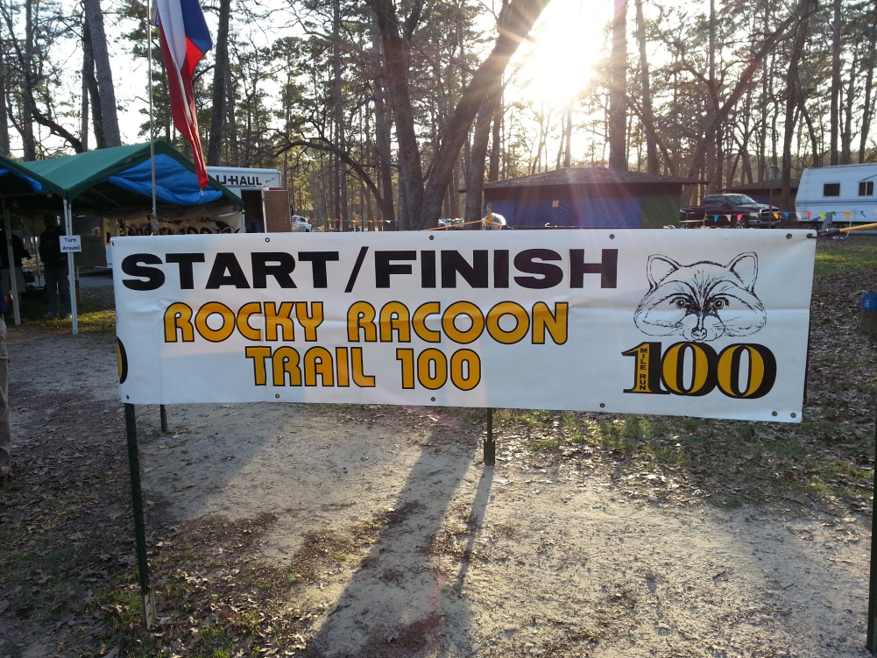
The rest of the story:
The race took me 25 hours and 30 minutes. Of the 406 who started the race, only 206 finished. I was number 109. My race pace fluctuated greatly. As the pain came, my pace slowed. I ended up averaging a 15 min mile.
There is wisdom in recognizing the limits of the human body if the physiological and psychological systems are not in sync. Remember that painful right leg that began hampering me at mile 60? Two days after finishing the race I found myself in another faraway place from home giving a seminar on not taking the marshmallow. I woke up on day one of the program to find my right leg had swollen to the size of large sumo wrestler. I immediately fly home and checked myself into the hospital. Tests were quickly completed and I was admitted to the hospital and was warned of 3 dangerous conditions occurring in his body.
Condition one: My right leg calf muscle was compromised. My body fat percentage was too low and my doctor hypnotized that as a result, somewhere in the midst of the 100 miles, having not consumed enough calories, my body began consuming itself, in this case my calf muscle as a way to feed the energy needed to keep going.
Condition two: My liver was at a very dangerous low level of workability, the result of over taxing my body. The liver filters or detoxifies the blood as well as breaks down substances we put in the body, like alcohol, caffeine as well as toxic chemicals the body naturally produces. The liver acts as a filter to clean our blood. My liver was in trouble, but was able to get stabilized since getting to the hospital and getting some attention.
Condition three: My kidneys were at a very dangerous low level of functionality. The kidneys manage our waste excretion process, our water levels, blood pressure, red blood cell regulation as well as acid regulation. A person runs into kidney issues when conditions like dehydration, urinary tract infections, blood clotting or infection are present.
I ended up staying in the hospital for 3 days, where doctors worked to stabilize my liver and kidneys. In addition, there was damage to my right leg and I did not have very good use of it for the next month. Crazy enough I had to use a wheel chair and crutches for the next month.
Yes I finished the race. Yes I pushed my own known limits of willpower to complete the 100 miler. No, I was not wise to continue the race while not providing my body the energy and nutrients it needed to complete the course.
Did I win? Well I got what I wanted, but not what I asked for. I violated the laws of the balance required between physiological and psychological wellbeing. The body is a machine. Your body will perform if you train, teach, fuel and manage it. If you don’t, the gas runs out, engine failure. Failure to take care of the machine results in an inoperable machine over the long run.

