What is the body language of leaders on high and low power confidence: And how does the leaders body language affect follower support?
Susan Constantine
September 11, 2014

ABSTRACT
Business leaders can lose or gain the support of non-leaders through ones body language. Leaders sending high-power confidence gestures can increase the support of non-leaders whereas; leaders sending low-power gestures risk the support from non-leaders significantly. A leaders body language can communicate to non-leaders varying messages of like-dislike, high vs. low power, leadership, discomfort and insecurity, social attractiveness, persuasiveness, all of which can impact how non-leaders perceive a leaders level of competence and confidence. Since business leadership is under the microscope of employees, leaders must be cognizant what messages their body language is sending. Research finds that leaders demonstrating high-power gestures are perceived as more confident and competent than leaders demonstrating low-power gestures. This literature review investigates present and past studies on high and lower power gestures of leaders, and to advance the research to include how political and religious leaders body language impacts voters and religious supporters. Present research will show that business and political leaders who exhibited high power gestures were seen as more confident and competent, whereas, religious leader who exhibited high power gestures where perceived as overpowering. Religious figures that use palms-up gestures were perceived as humble servant leaders, trustworthy, competent and confident as seen by religious supporters

TABLE OF CONTENTS
CHAPTER 1
Introduction………………………………………………………………………………………5
In the Context of Leadership What are Supporters and Followers?
Historical Researchers on Body Language
Research Linking Facial Expressions with Emotions
Study of Gestures
CHAPTER 2
Literature Review………………………………………………………………………………10
CHAPTER 3
Methodology…………………………………………………………………………………….14
Purpose of Study.…………………………………………………………………………14
Design of Study…………………………………………………………………………..15
Target Population and Participant Selection……………………………………………..16
Procedure and Research Approach………………………………………………………16
Instruments………………………………………………………………………………18
Reliability and Validity…………………………………………………………………..21
Research Questions and Hypotheses……………………………………………………..21
CHAPTER 4
Expected Results/Findings…………………………………………………………………… 22
Expected Results………………………………………………………………………………..22
CHAPTER 5
DISCUSSION…………………………………………………………………………………..23
Photos……………………………………………………………………………………………27
CONCLUSION…………………………………………………………………………………32
REFERENCES………………………………………………………………………………….33

CHAPTER 1
Introduction
Does the body language of leaders impact follower support? And if so, what is the body language of leaders that gains the support of followers? Are there specific gestures that exhibit high confidence vs. low confidence, high power vs. low power? Are gestures universal or cultural? Is there a difference between how supporters view business, political and religious leaders in high and low power gestures? What is the impact of exhibiting high and low power gestures to diverse groups? These are some of the questions explored in this research proposal, intends to answer and to further current research to include if the body language of business leaders is the same as political or religious leaders, and how supporters interpret these gestures?
Research has shown that in a matter of second’s supporters perceived the level of confidence, competence and credibility through a leaders body language, hand gestures and facial expressions. Studies have shown that humans send and receive approximately 4000 nonverbal messages between two individuals in just one hour. Meaning our body language communicates a message without saying a word. Mehrabian (1971) found that fifty one percent of communication is exhibited through body language; thirty eight percent is in the voice (i.e voice tone, inflection, pace, rhythm and speed), and seven percent in the spoken word. Other renowned researchers in human behaviors, and emotions include Dr. Paul Ekman , a psychologist who studied universal facial expressions and emotions. Dr. David Givens (2014) studied gestures and their meanings, and Charles Darwin (1998) researched behaviors of humans and primates.
In this research proposal, the focus is to determine “what is the body language of leaders in high and low power confidence” and how the body language of leaders impacts follower support? For the purposes of this review, leaders are referenced as (i.e managers, supervisors, CEO’s, politicians and religious figures), supporters are non-leaders (i.e employees, voters, and church members). Leaders according to the Campbell, (1997) from the University of Missouri defines leadership is the actions by one or more persons that influence (guides) the behavior of one or more persons in a group setting by which the leaders actions are meant to influence, or to change the behavior of other people most often of the group. Leadership cannot occur without the consent of the people (the "followers or supporters"). A leaders primary function is “empowering" people to accomplish a desired goal (Campbell, 1997).
Empowering people means giving people the beliefs and skills to take action themselves. At the small group or local level, empowering individuals can be accomplished through education, motivation and inspiration (Campbell, 1997). Body language is the nonverbal equivalent of words communicated through the use hand gestures, body movements, and facial expressions. The research literature proposes that body language can weaken or strengthen the position of leadership authority, which can positively or negatively affect follower support. This paper intends to show how the body language of leaders can send a message of high confidence vs. low confidence through the nonverbal communication channels. Leader directives are dependent on sending a clear congruent message to their supporters in order to gain their confidence that the leader is competent to lead them.
Historical Researchers on Body Language
Classic research on body language dates back to the late 1800’s when Charles Darwin was the first who was able predict a subject’s outcome by documenting facial expressions and demeanor. Darwin believed all humans regardless of ones origin exhibit the same nonverbal facial displays of sadness, happiness, anger, surprise and fear. Charles Darwin’s (1872/1965) book The Expression of the Emotions in Man and Animals has been highly influential for research on emotions (almost 3,000 citations according to the Institute for Scientific Information (Hess & Thibault, 2009). Darwin believed that facial expressions were linked to human emotions, meaning the face reveals a person true emotional state. In 1968 Dr. Paul Ekman furthered Darwin’s research to find if facial expressions were universal or culture specific, and to settle the debate whether facial behaviors were associated with emotion.
In a series of groundbreaking research publications co-authored with Wallace Friesen he provided strong evidence in support of the hypothesis that the association between certain facial muscular expressions and discrete emotions is universal (Baxter & Webb, 2012-2013). According to Baxter & Webb, (2013) Ekman’s work was noted by The American Psychological Association named Ekman as one of the 100 most influential psychologists of the 20th century and he was selected by Time Magazine as one of the 100 most influential people of 2009.
What is Body Language?
Body Language is communication. A book called Communication Beyond Boundaries describes body language as nonverbal communication that is an outward reflection of a person’s emotional condition (Payal, 2014) stating that nonverbal more than verbal communication reveals the true attitudes and emotions of people, often without their conscious awareness. The definition of body language remains consistent with numerous experts who have studied nonverbal communication. In this review there is compelling evidence that people both consciously and subconsciously tend to reveal ones likes and dislikes through their body language (Payal, 2014) This belief remains consistent among researchers in nonverbal communication. Darwin stated that the face reveals a persons emotional state.
Ekman confirmed that emotions reveal a person emotional state and goes on to say that facial expressions are universal, meaning every human being regardless where they live in the world exhibit the same expressions of anger, surprise, happiness, disgust, contempt, fear and sadness. The nonverbal process of using facial expressions, gestures, gaze, tone of voice and postures are to send and receive wordless messages. Body language communicates both positive and negative emotions for example; negative clusters of emotions can be seen with a clenching fist, furrowed eyebrows, folded arms to a contemptuous smirk. Where positive emotional clusters can be seen with a head nod, leading head to one side in an active listening position, palms up hand gestures and genuine eye contact. Researchers who have studied nonverbal communication all agree that body language is a powerful communicator.
The Link Between Facial Expressions and Emotions
The literature shows that Charles Darwin was the first to conduct research on the topic of
expressions of man and animals. An experiment conducted by Darwin was the very first study on
how people recognize emotion in faces. Darwin’s work expanded to study the university of facial
expressions. Darwin began by compiling photographs to illustrate the different expressions of his
research. Darwin studied the emotion of expressions to answer why do particular expressions
form a particular emotion.
Literature written by Ekman found that facial expressions were directly linked to
emotions and furthered showed that if one manipulated their facial muscles to take on the facial
characteristics of any of the seven universal expressions, the emotions would follow. In an article
called Facial Expressions and Emotion written at Vanderbilt University by Nassif &
Shellow (2014) reported studies show that smiling can make you happier by manipulating your
facial muscles into a smile can create a subjective feeling of happiness. Psychologists refer to
this phenomenon as the “facial feedback hypothesis (Nassif & Shellow, 2014). There is
compelling research literature that dates from the 1800’s to 2014 that concurs that there is evidence that emotions and face expressions are linked. A leader facial expression cans giveaway envoke positive or negative reactions from supporters. A furrowed eyebrow, tighten lips, and narrows eyes can be seen as angry person which can affect the support of followers.
Hand Gestures
According to Dictionary.com, gestures is defined as a movement or position of the hand,
arm, body, head, or face that is expressive of an idea, opinion, emotion. Merriam-Webster defines gestures as a movement of your body (especially of your hands and arms) that shows or emphasizes an idea or a feeling, something said or done to show a particular feeling or attitude. The placement and movement of the hands is an expression, the same as the face. The hands can express an idea, feelings, or an attitude of the leader. The literature reviewed sheds light upon how gestures communicate ideas both positive and negative.
CHAPTER 2
Literature Review
Sending a weak nonverbal message can have a devastating affect on a business. Companies spend millions of dollars hiring leadership coaches to train senior leaders how to give a powerful presentation, communicate more effectively, and to be more persuasion. Companies are reaching out to body language experts and leadership coaches to teach their leaders how to use their body language to lead, inspire and motivate teams. The fascination to understand human behavior has caught the attention of the national media. Experts are called to analyze the body language of business, political, and religious leaders to interpret nonverbal signals to determine if a leader is trustworthy, confident and competent. Companies are particularly interested to insure their leaders are sending the correct message and to learn the body language of leaders.
In this research proposal, there are numerous literature sources that address different
ways leaders communicate through their body language, facial expressions and gestures. Because of the demand of companies seeking training to better understand how to appear trustworthy, confidence and competence there are numerous sources to conclude and synthesize the research and propose to answer these research questions. Reliable and respected scholars provide valuable information to evaluate what is the body language of leaders in high and low power confidence, and how a leader body language affects follower support. The literature sources are scholarly peer-reviewed research articles that have a high level of reliability and validity. Books, and additional articles written by leading professionals specializing in nonverbal communication have been included in the proposal.
According to Dr. Carol Kinsey Goman, (2011) author of the book “ The Silent Language of Leaders addresses how body language can help or hurt leaders to lead. Gorman states that a leader words must be congruent with the leaders body language to avoid miscommunication. Gorman addresses the differences between the body language of male and female leaders. Gorman conducted research with managers in the United States, Canada and Europe seeking answers to masculine verses feminine communication styles and the challenges and opportunities that these styles present in business. The research concluded that the top three communication strengths of male leaders are their physical presence, meaning male leaders are bigger and look more powerful, men keep a poker face showing they can control their emotions, and men have a confident “power stance” in which they spread out and take up more room.
Women make more eye contact, tilt their held in an active listening position, and have an appropriate display of empathy on their face. Gorman, (2011) states female’s strength can also be perceived as weakness if over accentuated by over-gesturing, which can be perceived as confusing and ambiguous. Avoid maintaining a head tilt too long, which can dilute the female leaders authority. Gorman states that females seeking authority and credibly should keep their voices down to avoid the voice sounding pitched, broaden ones stance to compensate for their stature. Smile selectively when discussing a serious matter, avoid self-pacifying gestures by rubbing hands together or stroking arms or hair, keep the head straight to project authority and confidence, and employ a firm hand shake.
Male leaders send more power gestures and cautioned too avoid overpowering non-leaders and appearing cold and uncaring. Male leaders must be flexible and modify their body language when giving directives. The most powerful gesture for male leaders is hands on the hips, legs solidly planted on the floor with legs spread slightly wider than ones shoulders, with a neutral facial expression. According to Dr. Amy Cuddy, (2013) a professor of Harvard Business School supports in part with Gorman research by stating that leaders expand their body language and take up more space, but adds that an open posture reflects high power, whereas low power is more constrictive with closed postures (Carney, Hall, & Smith LeBeau, 2005; Darwin, 1872/2009; de Wall, 1998; Hall, Coats, & Smith LeBeau, 2005). Cuddy, (2013) does not address gender differences.
In an article written by Casasanto & Jasmin (2010) called “Good and Bad in the Hands of Politicians” investigated if the way people conceptualize and communicate ideas with positive and negative emotional valence are linked to the way they use their hands. The researchers wanted to determine if the way people communicate ideas with positive and negative emotional valence is linked to the way they perform actions with their body. To test this, the researchers used the final US presidential debates from 2004 and 2008 (Cassasanto & Jasmin, 2010). Both of the candidates from 2004 were right-handed (John Kerry, Democrat; George W. Bush, Republican), and both candidates from 2008 were left-handed (Barack Obama, Democrat; John McCain, Republican. In both of the left-handed candidates, left-hand gestures were more strongly associated with positive-valence clauses, and right-hand gestures with negative-valence clauses; in both right-handed candidates, right-hand gestures were more strongly associated with positive-valence clauses, and left-hand gestures with negative-valence clauses (Cassasanto & Jasmin, 2010). This adds an additional piece to how leaders communicate both positive and negative information. Tracking the hands gestures gives way to how the leader views specific political viewpoints.
David B Givens, (2014) from Center for Nonverbal Studies, Spokane, Washington USA
reaseaached hand gestures and their meanings. Givens is a renowned author on body language and has conducted massive research for trade journals, publications, and college textbooks. For the purposes of this paper, Givens provided this writer his most current research that has not yet been made public, but was given permission to provide his research for this study. According to Givens, (2014) leaders with low confidence used palm-up cues that express varying degrees of emotional helplessness, cognitive uncertainty, prosodic emphasis, and social deference. Givens stated that palms up gestures by themselves, or in combination with other hand movements--such as reaching, showing, pleading, and pointing--palm-up cues are used to begin speaking turns, ask questions, request favors, and share personal opinions, feelings, and moods. For example, in the boardroom, an American CEO appeals to senior staff with a palm-up gesture and implores, "I need your help."
Muller (2004) saw palm-up cues as a means by which speakers could “hold” and present ideas to listeners. Ekman and Friesen (1968) viewed hand-shrugs as emotionally expressive signs of helpless uncertainty and confusion. Streeck (2009) viewed palm-up signs as devices to help speakers and listeners coordinate speaking turns. In contrast to palm-up, Givens found that the palm-down cue is an insistent speaking gesture made with the fingers extended and the hand(s) rotated to a pronated position. The hands and forearms assume the position used in a floor pushup. To make a verbal statement stronger, speakers rotate the palms downward as if preparing the body to press-up to a more aggressive high-stand display.
Upon compiling research to determine what is the body language of leaders in high and low power confidence one of the challenges are that hand gestures unlike facial expression has many meanings. The research conducted by Givens (2014) stated that hand gestures are often synced with verbal communication. For example a leader may motion a palms-up gesture, with a verbal command “Come over here!” Palms-up gestures can be used to elicit information from a supporter. Leaders may use the palm-up gesture for combination of commands in the right context. Palms downs gestures are insistent speaking gesture, which is a stronger command of authority.
The researched reviewed for this study shows leaders how they ought to use body language to convey information to supporters. To appear more confident, the research suggests leaders to expand their body language and take up more space. Confident facial expressions of leaders should remain neutral when conveying important information to supporters. This was consistent among both female and male leaders. Gesturing with the leaders dominant hand conveys positive information whereas the non-dominate hand conveys negative information. Hand gestures used in the right context with speech can be used as a useful tool to communicate varying messages to supporters.
CHAPTER 3
Methodology
The purpose of this study is to investigate how effective leaders communicate verbal and nonverbally. To determine if there are specific body language gestures, hand movements, voice tone, facial expressions and language that projects power, confidence and competence. This study seeks to identify what is the body language of a leader and the impact the leaders body language has on supporters. To determine what verbal and nonverbal gestures, hand movements, facial expressions that communicates high power verses low power, and the affects it has on supporters. The research methods in the study are qualitative. Participants in this study will be filling out questionnaire form after viewing photos of subjects to determine which candidate appears more or less confident and competent to lead supporters in business. This is a simple task and easily followed by cross sections of ethnicities and cultural groups living in the United States.
Purpose of Study
The purpose of this research is to find out whether high vs. low confidence gestures inpact follower support. This research proposal seeks to investigate if a leaders high power confidence gestures are more effective or less effective than low power confidence. Meaning, do leaders who exhibit low vs. high power gestures gain or lose the confidence from supporters to lead them. Companies have a lot at stake and money invested in cultivating and training leaders. If a leader is does not gain the support from non-leaders the leader efforts can be lost or gained by the message their sending through their body language. If a leader appears less confident and competent then supporters may not have the respect for the leader.
Conversely, a leader who appears confident may gain the respect and direction from their leader. This study looks to scholarly experts to determine what gestures are considered to more or less confident and competent and if the body. In an article written by Amy Cuddy (2013) called Your Body Language Shapes Who You Are states that “leaders are challenged by those who already project power and competence to the world through their bodies, there is another, perhaps harder challenge: communicating warmth.” Cuddy, (2013) goes on to include a variable to consider which is a leaders must understand the people you're trying to influence or lead by building trust first before demonstrating competence and power. You must be able to show them that you understand them -- and, better yet, that you can relate to them (Cuddy, 2013). Trust is proposed along with confidence and competence to be viewed as a effective leader.
Design of the Study
The design of this proposed study is a quantitative. This study is a single pronged and is a method to helpful in evaluate the date because it provides quantifiable and easy to understand results. In conducting this research study participants were to determine what is the body language of a leader that is perceived as being more of less powerful. Participants were randomly assigned of a sample size of 61 persons that consisted of (40 women and 21 men; 22 white, 12 black, 20 Asian, 5 Latino, 2 ―other men and women). Each participant was asked to view photos of leaders posed in low and high power poses. Power posing with hands on hips in a superman pose (i.e., expansive and open) verses low- power (i.e., constrictive) candlestick position. Participants were asked to view pictures and were asked to form opinions about the people in the pictures rating photos 1-5 as having the most and least power. After completing this task participants were asked participants was asked to fill out a questionnaire rating the photos 1-5. One have the most power and confidence and five having the least power and confidence. The questionnaires were gathered and calculated to determine which photos appeared to have high or low power.
Target Population
The sample size consists of 61 students from Florida State University, which consisted of (40 women and 21 men; 22 white, 12 black, 20 Asian, 5 Latino, 2 ―other men and women). The study will focus on the age group between the ages 19-25. This age group selected is student who has not worked Procedure and Research Approach d in a corporate environment to remove any bias from previous work experiences with business leaders. Each of the students is enrolled in a Business degree program or an MBA at the University. Each of the participants must fill out a informed consent to protect the candidate from harm, and to allow the results of the study to be used for research and publication purposes.
Procedure and Research Approach
On the day of the testing the procedure the research administrator will debrief the candidate at least two weeks prior the study. A letter will be sent to each of the candidates with a leaflet and instructions, and sample question to provide some insight to what to expect on the day of the research study. Each candidate must sign an informed consent agreement agreeing to participate in the study. Once the day arrives the research administrator build good rapport with the candidates to put them at ease and provide a safe environment to ask and answers questions. The administrator will come prepared with an introduction checklist to assure one cover all the key elements of the research study. The introduction checklist ranges from ones personal introduction to eliciting feedback.
There are six elements in research administration, which are preparing for the study, briefing candidates, instructing and debriefing candidates after the study, and scoring the test and managing the results (Cook 2005). Prior to conducting the study the administrator must be
fully versed in conducting research studies. It is important that the administrator had conducted similar studies in the past. Before the administrator begins the study one should evaluated the study environment to make sure the area is free from distractions. Distractions that could hinder concentration are noise and unnecessary activity in the room or neighboring rooms that are in close proximity to the research study area (Crips, 2005).
This research proposal will be a single pronged research approach because it is dependent upon the participant’s first impression of the photos viewed. This is a case study approach that analyzes the body language of a leader in various body language stances on a first impression basis. The participants will be handed a questionnaire in which they will be instructed to keep with them throughout the testing period. The participants are timed throughout the test. Each participant will give thirty seconds to view each of the photos before marking their questionnaire.
The participant will be instructed not to change their decision on a specific photo. The participant’s are asked to score the candidates in photos from 1-5 to which candidates appear to have high or low confidence. The research administrator will not rush the participants and will be provided ample space between the other participants to stretch out and have room for viewing the photographs. The administrator will set a time for the test, in the morning rather than afternoon. Once the test is completed the administrator collected the questionnaires and prepare the testing log for the recording date, time, whom is being tested, the testing instrument, any problems that arise, general comments and observations. A stopwatch will be timed to the second (Cook, 1995).
Instruments
Since this research will be based on the raters first impression of the leader. Individual raters will be asked to look at a photo, and they have 30 seconds to decide the level of competency of the person on the photo. Each rater will be timed not to exceed 30 seconds. Three of the raters were excluded because they recognized the person in the photo. The sample size dropped to 38 raters instead of 40. The questionnaire was created specifically for this test and the raters were given one copy of the questionnaire score sheet. One copy will be provided to eliminate a second chance visual test, which will prohibit the raters to change their minds. This test will be conducted over a thirty-day period in order to test the reliability and validity. The scores of the test will be incorporated into the case study for analysis. Items measured on a Likert scale – ranking photos on scale of 1-5.
- 1 = Very incompetent
- 2 = Somewhat incompetent
- 3 = Neutral
- 4 = Somewhat competent
5 = Very competent
Materials
The raters will be given (6) 5X7 glossy photos. Each photo will be marked on the back of each photo in black ink. Each number will be circled to ensure the rater correlated the correct photo with the number listed in the questionnaire. The raters will be given (1) pen and (1) questionnaire to document their score. Raters are not permitted to use pencils or their own writing tool. All the raters will be given the same photos in the same order to prevent any errors.
ANALYSIS OF TECHNIGUES USED
This research proposal used questionnaires to collect the data from raters. Additional SPSS data analysis ought to be used to further investigate the data collection.
Questionnaire
Each rater would be given (1) questionnaire to document their findings. The test adminstartor would collect the questionnaire from each participant immediately after completing the task of rating the photos. The test administrator would compile the questionnaires and examine them to make sure there were no others markings on the form. The data from the thirty eight participants would be collected and entered into an excel spreadsheet in alphabetical order by participants name and number. The data would be entered into a SPSS statistical data program to analyze the data and create a table and graph to determine the results the data collection.
Note. 1=completely incompetent, 2=somewhat incompetent, 3=neutral, 4=somewhat competent, 5=very competent
Participant | Photo 1 score
1 | 5
Table 1

Sample Questionnaire

Low vs. High Power Confidence
Tester | Susan Constantine | Raters Name
Case Study: | What is the Body language of Leaders? | Date:
Test time | [Type a period name] | Results:
Instructions
Please look at the following pictures. Assume that each photo is a business leader. Rate each of the photos from 1-5 as to how competent they look. This is based on your first impression, and yow will have you will have 30 seconds to view the photo and write your score below. How competent is the person in photo? (1 = completely incompetent…. 5 = extremely competent)

PHOTO 1
Score _________________

PHOTO 2
Score_________________

PHOTO 3
Score_________________

PHOTO 4
Score_________________

PHOTO 5
Score - L subject________

Score – R subject________

PHOTO 6
Score__________________

PHOTO 7
Score 7_________________
Answers | Total Number of Participants (36)
Completely incompetent
Somewhat incompetent
Neutral | 1
Somewhat competent | 3
Completely competent | 33
High Power Confidence Gestures

Answers | Total Number of Participants
Completely incompetent | 33
Somewhat incompetent | 3
Neutral | 1
Somewhat competent
Completely competent
Low Power Confidence Gestures
CHAPTER 4
Reliability and Validity
The sample collection was chosen for validations in which involved collecting and analyzing data to assess the accuracy of an instrument, in this case study questionnaires. Then the items measured on a Likert scale – ranking photos on scale of 1-5. The sample was from a variety of ethnicities. Although, the raters come from a variety of ethic backgrounds their career paths are similar. Each of the students is enrolled in a business program at Florida University. The reason for choosing this sample was to ensure the tests reliability would ensure the external validity to the extent to which the results of a study can be generalized from a sample to a population of 38. The inter-rater/observer reliability is the degree to which different raters/observers give consistent answers or estimates, in this case, college students.
Research Questions
The questionnaire is very simple, with one question that is asked, that is, does the person in the photo appear to have low or high power confidence. The likert-scales are in place to easily rank photos on a 1-5 scale from completely incompetent to highly competent.
The research questions that this proposal intends to answer in addition to which person appears more of less confident. Upon searching the literature, this writer seeks to answer why and what is it about the leaders body language that appears more or less confident.
How body language of leaders impact follower support?
What is the body language of leaders that gains the support of followers?
Are there specific gestures that exhibit high confidence vs. low confidence, high-power
vs. low power?
Are gestures universal or cultural? Is there a difference between how supporters view
business, political and religious leaders in high and low power gestures?
What is the impact of exhibiting high and low power gestures to diverse groups?
Expected Results
The expected findings for this research proposal will show that male leaders in business who expand their body language, maintain a neutral face when giving directives to non-leaders, use palms down gestures when making an important point are seen as confident and competent. Male leaders who stand with legs apart slight outside his shoulder frame with both or one hand on the hips are perceived as confident and competent. Female leaders who expand their body language and take up space are viewed as very confident and powerful. The expected finding will conclude that supporters who view leaders with low confidence body language are less prone to find the leader less competent to lead them. However, Supporters who viewed a leader exhibiting high power confidence body language would find the leader competent and confident to lead them.
The results are expected to have the same findings with voters viewing the body language of political leaders. The expected results of religious followers supporting religious leaders, the results should conclude followers are less prone to support a religious leader that exhibits power gestures. Religious followers support a leader with confidence that appear empathic in their body language.
Hypothesis
The null hypostasis is that the body language of leaders in high confident body language and competence are more prone to viewed as competent by supporters, whereas leaders in low confident body language are more prone to be viewed by supporters as less competent. Given the raters scores one could hypostasize that leaders should pay attention to how they are presenting themselves in front of non-leaders. The impact of low power confidence can deplete a leaders authority and impact follower support. A leader that unable to project trustworthiness, confidence and competence run the risk of losing the support of followers. This extends to political leaders but not entirely for religious leaders. Religious leaders who appear too powerful may be seen as less empathic and compassionate, and overly aggressive which could affect the support from their followers
Null hypothesis
That the body language of leaders has no impact on follower support
Alternative hypothesis
The body language of leaders can positively affect follower support

CHAPTER 5
Discussion
Business leaders can improve employee support by making small adjustments in how one communicates nonverbally. Many leaders have mastered their verbal skills in communicating directives, but with their greatest efforts can be lost if a leaders verbal skills are incongruent with their nonverbal message. When a business leaders verbal communication is aligned with their nonverbal message, a leader will gain the support of employees by sending a clearer message that is more easily understand when giving a directive. By making adjustments in ones body language, the leader will be perceived as more confident, competence, trustworthy and powerful. Many authors have provided subjective analysis of a business leaders body language, but ineffectively provide any clear research that supports “what is the body language of leaders,” and how a leaders body language affects employee support.
Books published on the subject provides interpretations of body language gestures and their meaning rather than instructing leaders how to convey a specific message using specific gestures synchronized with speech. An effective leadership coach who has been trained in nonverbal communication can improve a leaders effectiveness by teaching, training and instructing leaders how to use their body language to gain the support of employees to become a more effective leader by sending a clear congruent message. Learning and applying the body language of leaders one will become a more valuable asset to a company and the company’s stakeholders by improving a leaders verbal and nonverbal communication. By advising leaders how to use their hand gestures, voice, facial expressions, and body language when communicating to employees when giving directives, leaders can improve a company’s productivity thereby, increasing profitability.
Study focuses on hand gestures that have universal or culturally meanings, along with a dictionary of gestures and their meanings (Givens, 2014). A study focus on facial expression that give way to ones emotional cognition as well as physiological attributes of the face that provide insight as to leaders level of intellectualism. Additional studies analyze the first impression of a potential political leader face to determine which candidate is more confident and competent to carry the political position (Mattes, Spezio, Kim, Todorov, Adloph, & Alvarez). All of which has contributed in part to the study and understanding of nonverbal communication.
A leadership coach can work with leaders to improve their verbal and nonverbal skills one could videotape a leader giving a presentation. A videotape of the leader performance can be used to show the leader how one appears in front of an audience so that the coach can provide advice to correct bad habits. For example, a leader may not be aware that him/her arms are held close to ones side making the leader appear less confident, the coach can advise the leader to expand ones body language to appear more confident. The videotape can be used as a useful tool to correct bad habits and to form more effective nonverbal communication skills. To further previous studies this writer proposes how to read and interpret political leaders, and religious leaders nonverbal based from previous research on body language meanings.
To point out how political and religious leaders convey high or low confidence though ones body language gestures, facial expressions and speech. To provide videos of political leader, and religious leaders to participants who will rate the level of the leaders confidence and competence.
Limitations and Recommendations for Further Research
Can leaders correct low-power body language to high power body language, and is so, can a leader increase follower support? To move the research further to include: How do high power gestures of religious affect parishioner support? What is the body language of a religious leader? What is the body language of a political leader? To expand the current research to find if the body language of business leaders in high and low power confidence is the same amount political and religious leaders. And to find voters viewing political leaders using low power gestures in a towns hall rally verses a political debates where a political leaders uses high power gestures the outcome would be different. To further the study to find if religious supporters view the Pope using high powers gestures verses low power confidence gestures positive or negatively. The limitations is in this proposal based on review of the literatures, there is little research on genders and age differences among leaders.

Business Leaders
Photo 1
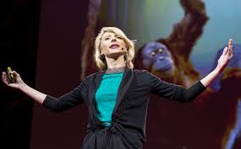
Figure 2

Photo 2
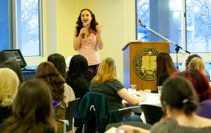
Figure 2

Photo 3
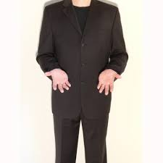
Figure 3

Photo 4

Figure 4

Political Leaders
PHOTO 5
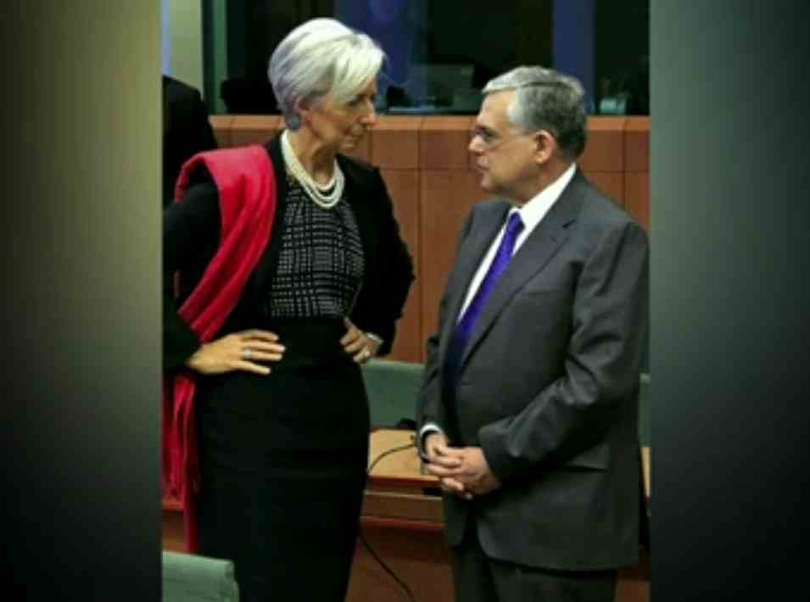
Figure 5
2012 Presidential Debates Body Language Expert Susan Constantine Weighs in on Fox
http://youtu.be/vAALnKMRlGc

Religious Leaders
Photo 6
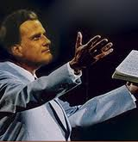
Figure 6

Photo 7
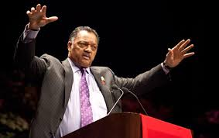
Figure

Findings
High Confidence
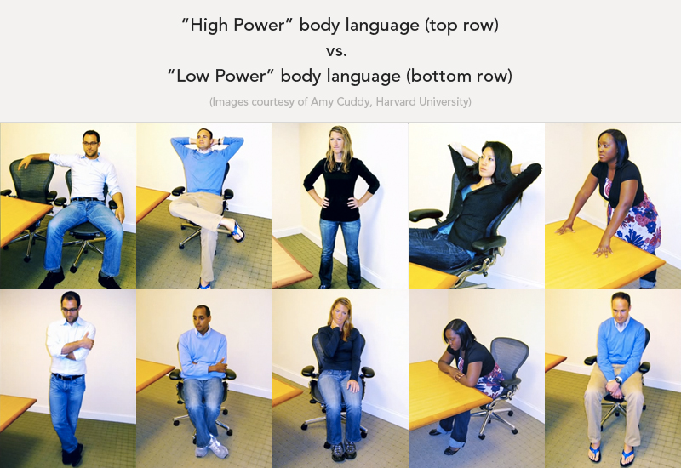
Figure 8

The Proposed findings of this study will conclude that low-power confidence gestures as seen on the above bottom row constrict their body language whereas high confidence gestures are expansive and widened.
Limitations
The limitations in the study are research on gender differences. Kinsey (2012) provides limited research on confidant and competent body language of females. Future studies focused on females in male dominate verses female dominate leadership roles can expand the current research available.

Furfure Research
To further this proposed research to expand the knowledge to include political and religious leaders. Continued research to determine if the body language of leaders expands to include political and religious leaders.
CONCLUSION
This proposed study to determine what is the body language of leaders in high and low power confidence concluded that raters view leaders that expand their body language, take up more space, use a combination of palms up and palms down hand gestures are viewed as completely competent. Based on the research leaders can use gestures to communicate different messages for example, palms-up gestures can be perceived as low power but in the certain situations palm-up gestures can express an idea, feelings, or an attitude of the leader. Palms-down gestures are seen when a leader makes a strong point. Both male and female leaders are viewed as more competent when they expand their body language, place hands on hips, with a neutral facial expression, whereas both male and female leaders who constrict their body language is viewed as less confident. Female leaders need to be cautions to over smile, or tilt their heads for an extended period because they can appear submissive, weak or overly empathic, although, a female greatest advantage is warmth and compassion. Male business leaders exhibiting high power gestures over an extended period can be perceived as overbearing. It is with almost absolute certainty that followers support leaders with high power confidence, than leaders exhibiting low power confidence.

References
Baxter, C. J., & Webb, D. (2012-2013). A Comprehensive Guide to the Fascinating Study of
Body Language. Retrieved from www.all-about-body-language.com/
Campbell, R. Chapter 2 - Leadership Principles 1-16 University of Missorri. (1997). Retrieved
from web.missouri.edu/.../Leadership/chapter2a.htm
Carney, D.R., Hall, J.A., & Smith LeBeau, L. (2005). Beliefs about the nonverbal expression of

social power. Journal of Nonverbal Behavior, 29, 105–123.

Casasanto D, Jasmin K (2010) Good and Bad in the Hands of Politicians: Spontaneous Gestures
during Positive and Negative Speech. PLoS ONE 5(7): e11805.
doi:10.1371/journal.pone.0011805
Cook, Mark, Barry Cripps. Psychological Assessment in the Workplace: A Manager's Guide.

John Wiley & Sons (STMS), 03/2005. VitalBook file
Cook, Mark, Barry Cripps. Psychological Assessment in the Workplace: A Manager's
Guide. John Wiley & Sons (STMS), 03/2005. VitalBook file
Cuddy, A. (2013). Your Body Language Shapes Who You Are. Retrieved from
www.huffingtonpost.com/.../body-language_b_245.
Cuddy, A., J Wimuth, C.A., & Carney, D.R (2012), August 31, 2012). The Benefit of Power Posing Before High Stakes Social Evaluation. Retrieved from dash.harvard.edu.bitstream/handle/1/9547823/13-027.pdf?sequence=1
Darwin, C. (1998). The expression of the emotions in man and animals. Oxford University Press. Times.
Ekman, Paul, and Wallace V. Friesen (1972). "Hand Movements." In Journal of
Communication (Vol. 22, Dec. 1972), pp. 353-74.

Givens, D (2014). READING PALM-UP CUES: Neurological Venues of a Common Hand
Gesture. Center for Nonverbal Studies, Spokane, Washington USA
Goman, C. K. (2011). The Secret Language of Leaders. San Francisco, CA: Jossey-Bass A
Wiley Imprint.
Hess, U., & Thibault, P. (2009, February-March 2009). Darwin and Emotion Expression. University of Quebec at Montreal, 120-128. Retrieved from www.ursulakhess.de/resources/HT09.pdf
Mehrabian, Albert (1971) Silent Messages, Wadsworth Publishing Co.

Mattes, K., M. Spezio, H. Kim, A. Todorov, R. Adolphs and R.M. Alvarez. 2009. “Predicting
election outcomes from positive and negative trait assessments of candidate images.”
Political Psychology 31(1):41–58.
Nassif, C., & Shellow, G. (2014). Facial Expressions and Emotions. Retrieved from https://my.vanderbilt.edu/.../facial-expressions-and-...
Payal, M. (2014). Communication beyond Boundries. [Adobe Digital Editions].. Retrieved from http://www.businessexpertpress.com/
Streeck, Jurgen (2009). Gesturecraft. The Manu-facture of Meaning (Philadelphia: John
Benjamins).
Todorov, A., Mandisodza, A.N.,Goren, A. & Hall (2005). Inferences of competence from faces
predict election outcomes. Science 308 (June 10, 1623-1626).

